**Action rules extraction on Fragile State Index**

**Department of Computer Science**

**University of North Carolina at Charlotte**

**INSTRUCTOR - ZBIGNIEW W.RAS**

**TEAM MEMBERS**

**Gowtham Bharadwaj (801101552)**

**Adithi Amuru (801099858)**

**Sharranya Kalaivanan (801092329)**

**Shashank Mohan (801099752)**

**INTRODUCTION**

The main goal of this project is to extract from the datasets for three consecutive years the rules of action and classification that describe the FSI. In order to evaluate the changes in the rules of action produced over the years, an additional six features must be applied to the data sets. Rules of action will specify what changes are needed to lower FSI in the values of classification apps. Data discretization and identification are also conducted for further data analysis.

**FRAGILE STATE INDEX**

The Fragile States Report is an annual report released by the United States, which since 2005 has been dreaming about tanking the Fund for Peace and the American Foreign Policy website. The index was intended to determine the susceptibility of states to confrontation or failure, listing all sovereign states with United Nations membership where adequate data are available for review. The ranking is based on the 12 criteria number of scores listed below. Every predictor is graded on a scale of 0 to 10, with 0 being the lowest, indicating the most stable, and 10 being the maximum, meaning the least stable.

The 12 indicators are as follows

* Security Apparatus
* Factionalized Elites
* Group Grievance
* Economic Decline and Property
* Uneven Economic Development
* Human Flight and Brain Drain
* State Legitimacy
* Public Services
* Human Rights and Rule of Law
* Demographic Pressures
* Refugees and Internally Displaced Persons
* External Intervention

**ADDITIONAL FEATURES(INDICATORS)**

We extend this analysis by adding six new features that can enable risk assessment and early dispute warning. The new features added are as follows.

**Prison Population**

When deciding whether a nation is vulnerable or not, the proportion of individuals who commit perjury of any kind to individuals who are not engaged in any crime is critical. The prison population is the number of adults and juvenile prisoners present per 1 million people.

**Homeless people due to Natural Disaster**

Each function reflects the number of people affected by natural disasters that lead to the loss of their shelter.

**Life expectancy at birth**

Life expectancy at birth is defined as how long if current death levels do not improve, an infant will expect to live on average.

**Environmental Performance Index ( EPI )**

The Environmental Performance Index (EPI) is a means for quantifying and numerically identifying a state's policies ' environmental performance.

**Infant Mortality Rate**

Infant mortality rate (IMR) is the death rate of 1000 live births for children under the age of one year. The level for a given region is the number of children who die under the age of one year, divided by the number of live births throughout the year, multiplied by 1,000.

**Education Index**

The Education Index was measured by combining average adult years of schooling with expected years of children's schooling, each receiving weighting of 50%.

**DATA EXTRACTION**

The values for the additional features were collected from various websites and merged for further study with the initial three consecutive years FSI dataset (2014-16). The database sources from which the information derived are listed below.

1. <http://databank.worldbank.org/data/home.aspx>
2. <http://hdr.undp.org/en/data>

**DATA PRE-PROCESSING**

The data obtained from the FSI website was not clean and therefore some pre-processing was performed before identification was used. The following steps are

1. Special characters were removed so that the sheets can be parsed by the WEKA tool.
2. Outliers were removed and replaced by mean values.
3. Rows having a lot of empty values were removed from the analysis.
4. Missing numeric values were updated by their mean values.
5. Converting each numeric column value in the range of 0 to 10.
6. Numeric values of the Decision Variable Total were replaced by Nominal Values based on the following table values.

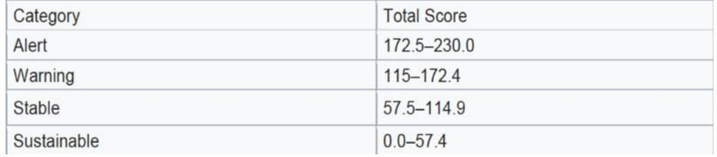

**YEAR - 2014**

**REPLACING MISSING VALUES**

Filter - ReplaceMissingValues

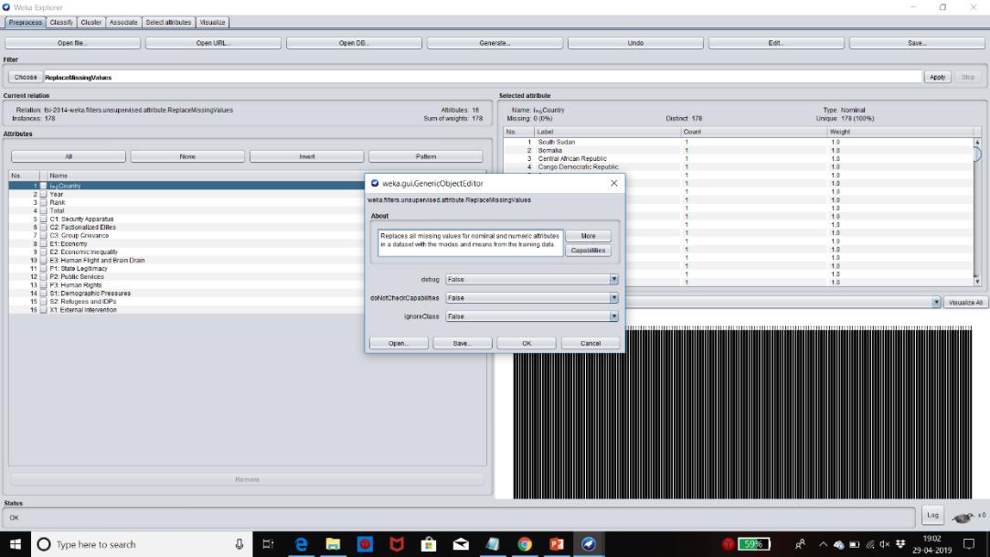

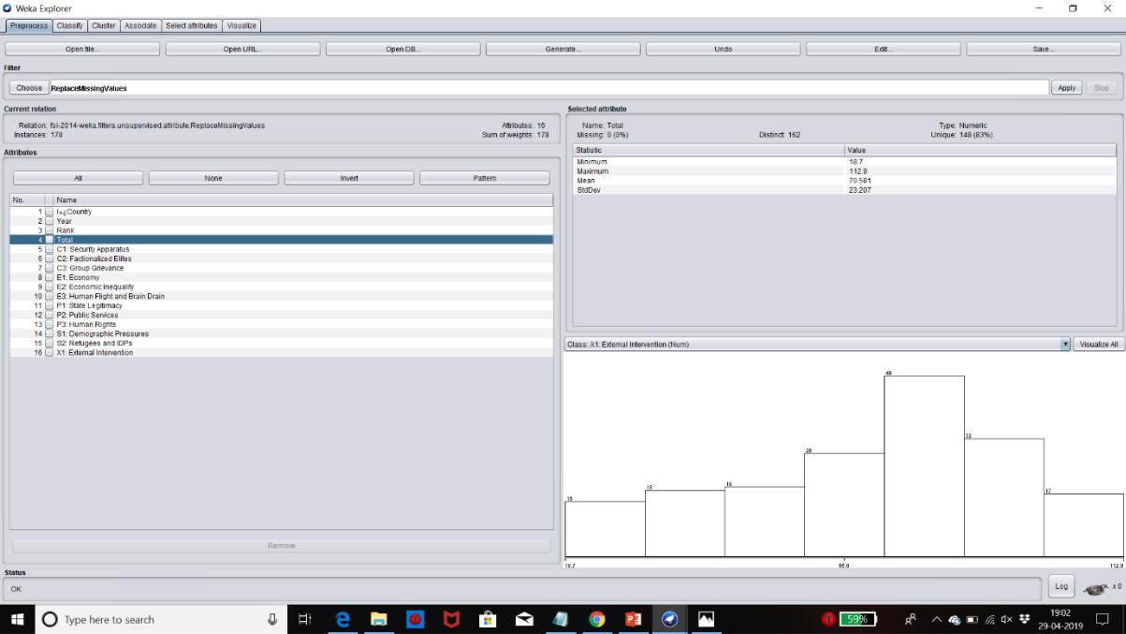

**OUTLIER REMOVAL**

Filter - Interquartile Range

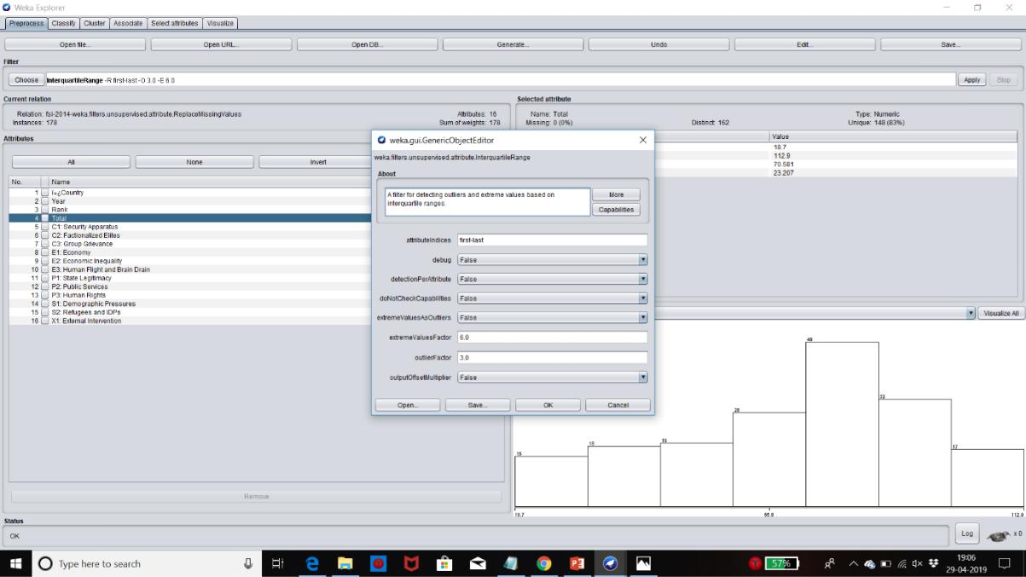

**DATA DISCRETIZATION USING WEKA**

The method of transforming an attribute of real value into an ordinal attribute or bins is called discretization. You can use the Discretize function to discretize the real-valued attributes in Weka.

Throughout the dataset, the decision attribute TOTAL has different values, we used discretization to replace TOTAL numerical values with the following concepts.

1. Alert (union of Very High Alert, High Alert, Alert)
2. Warning (union of High Warning, Elevated Warning, Warning).
3. Stable (union of Stable, More Stable, Very Stable).
4. Sustainable (union of Sustainable, Very Sustainable).

Filter used - Discretize

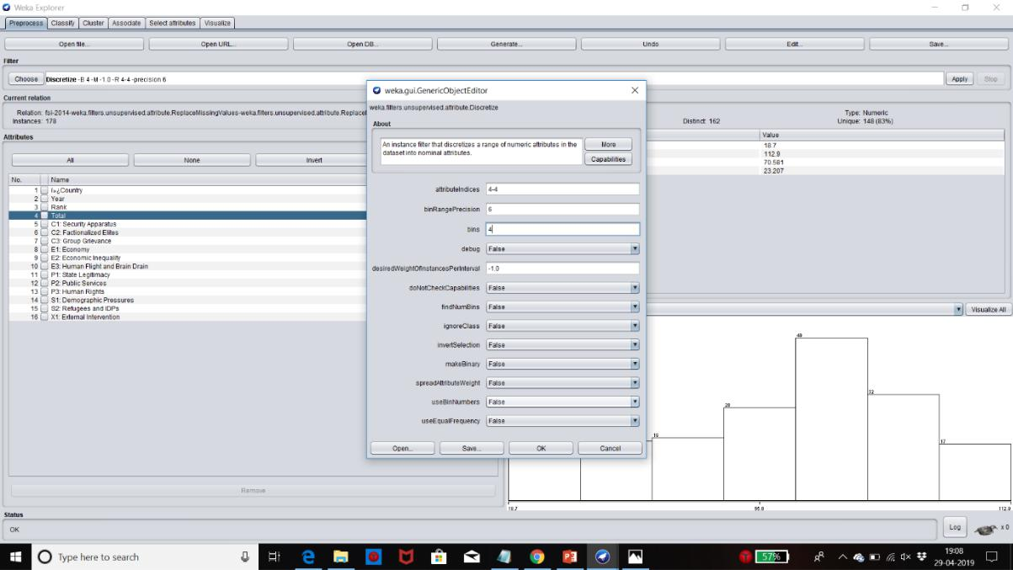

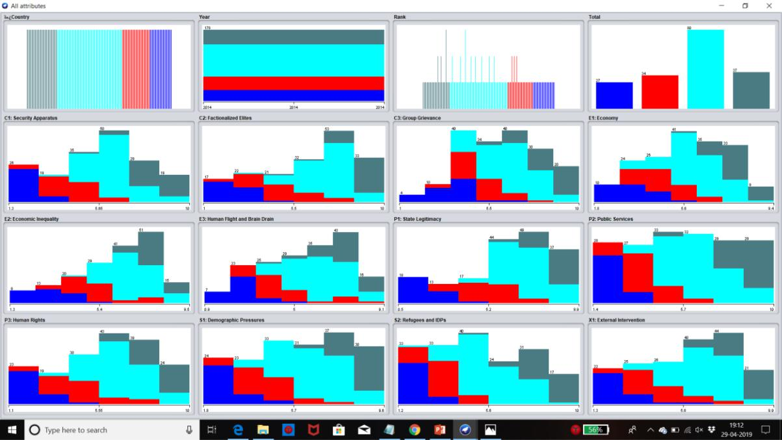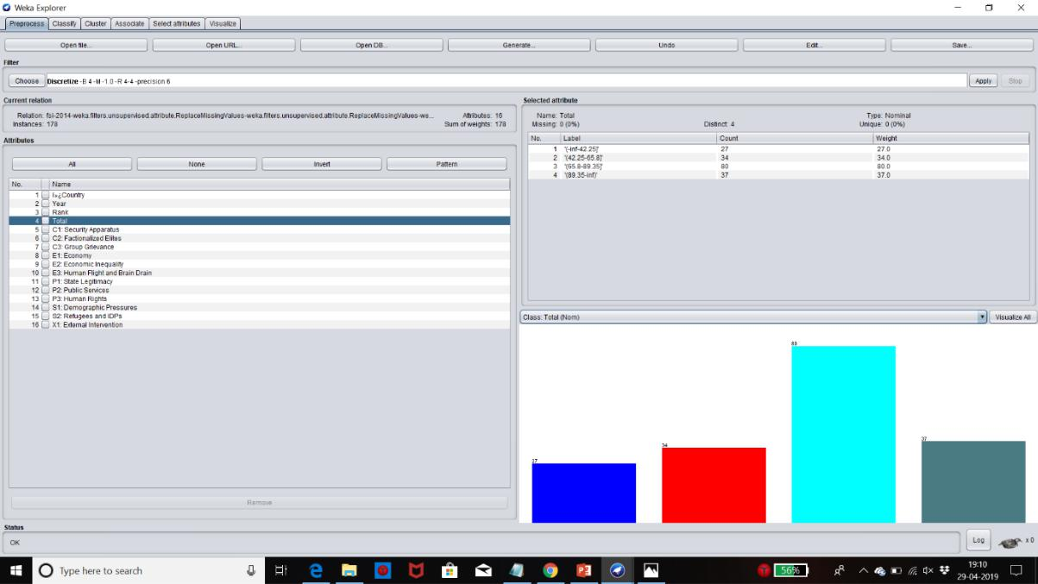

Saving this file in csv format

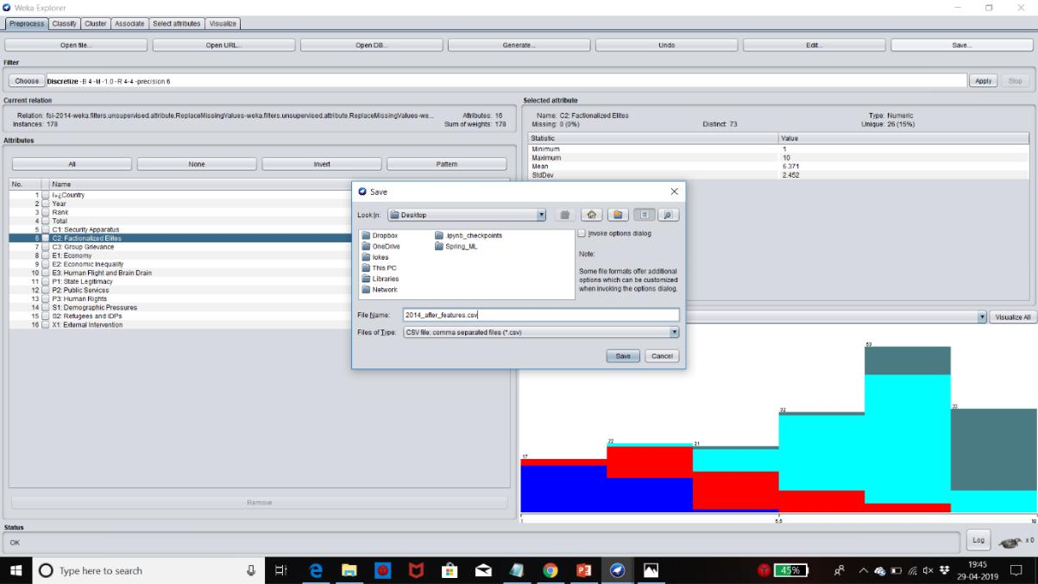

**YEAR – 2015**

**REPLACE MISSING VALUES**

Filter - ReplaceMissingValues

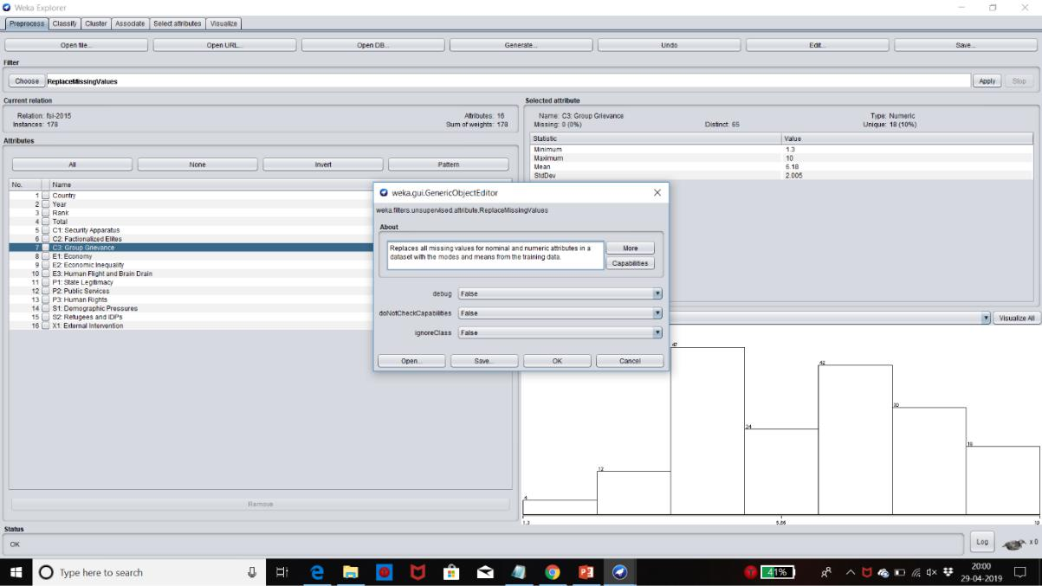

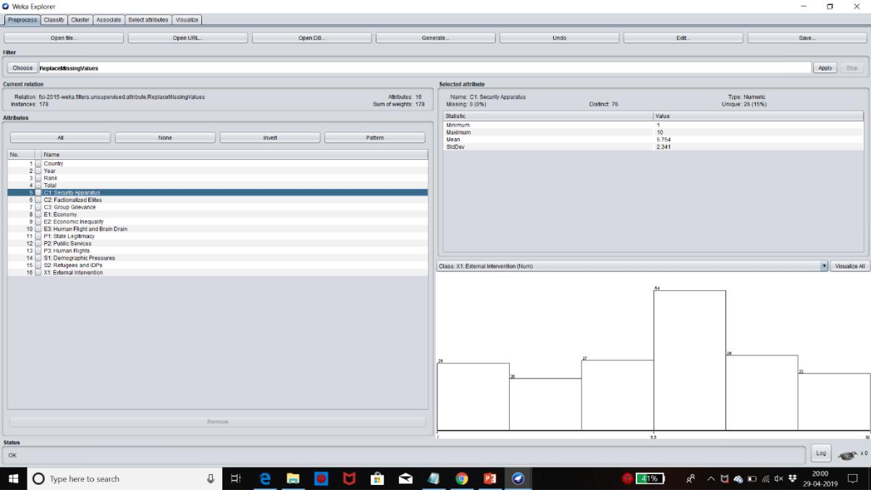

**OUTLIER REMOVAL**

Filter - Interquartile Range

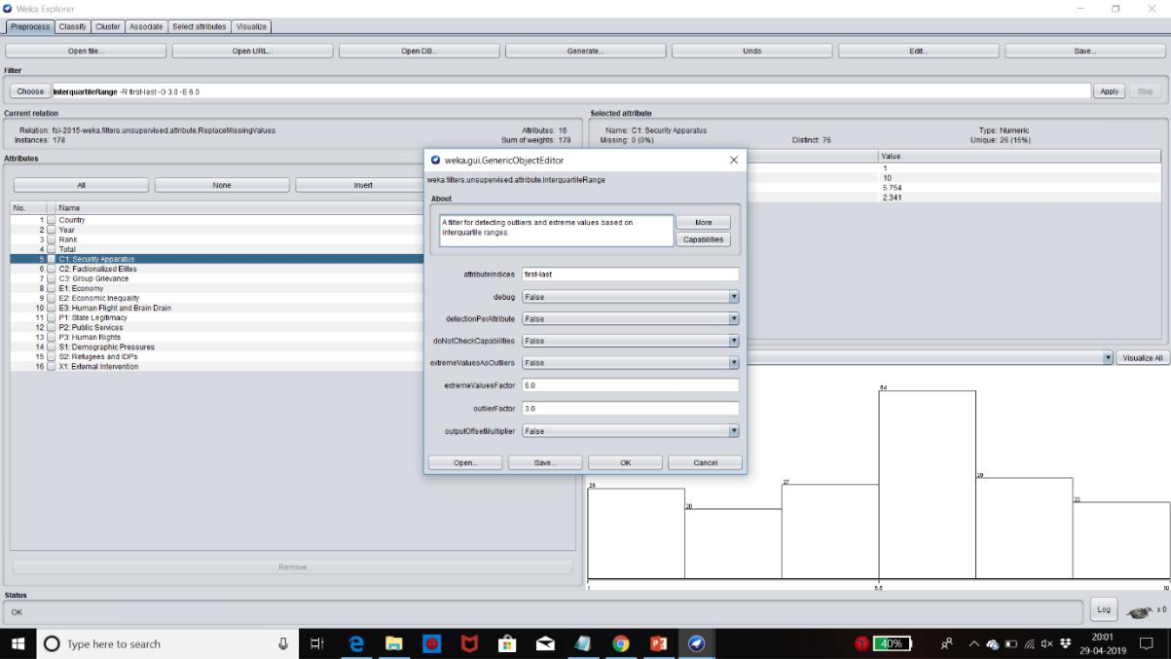

**DISCRETIZATION**

Filter used - Discretize

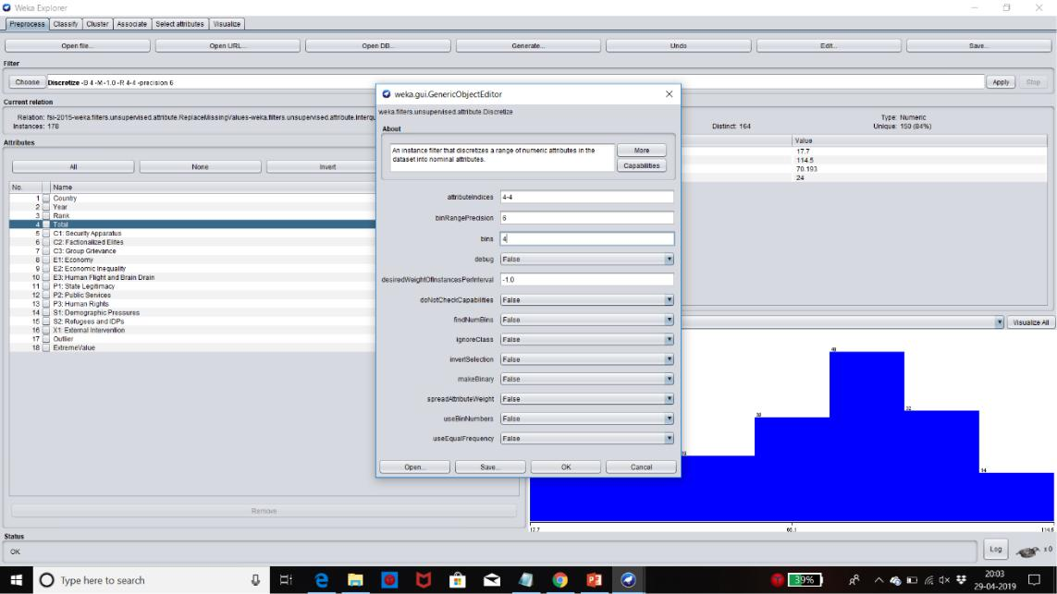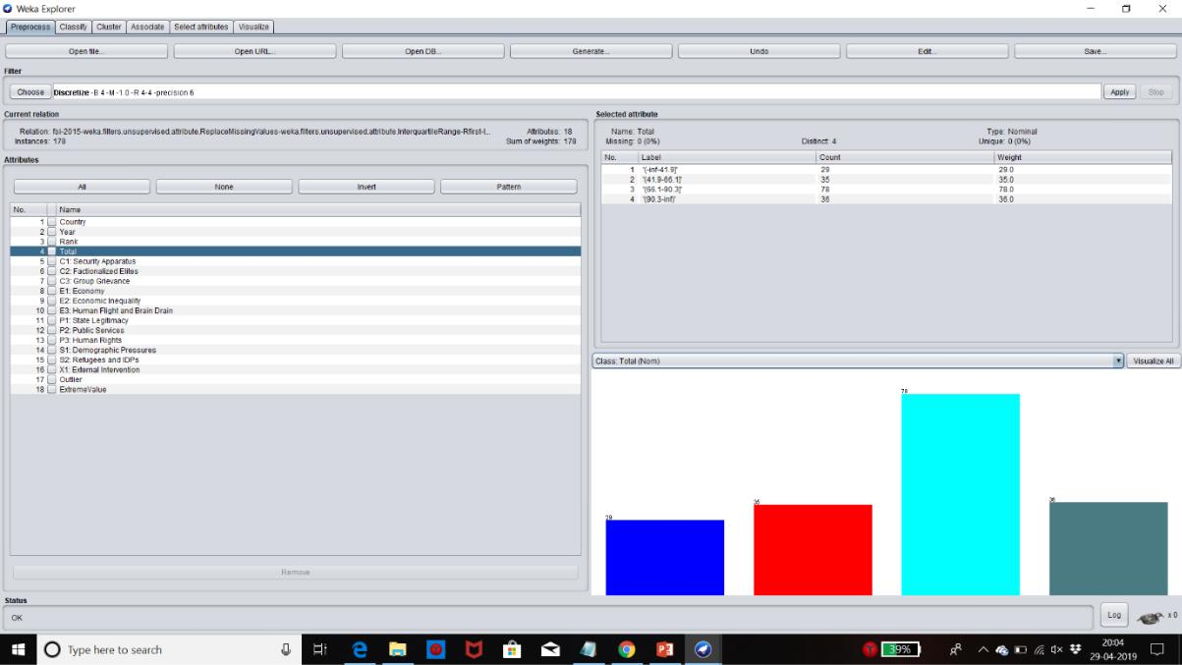

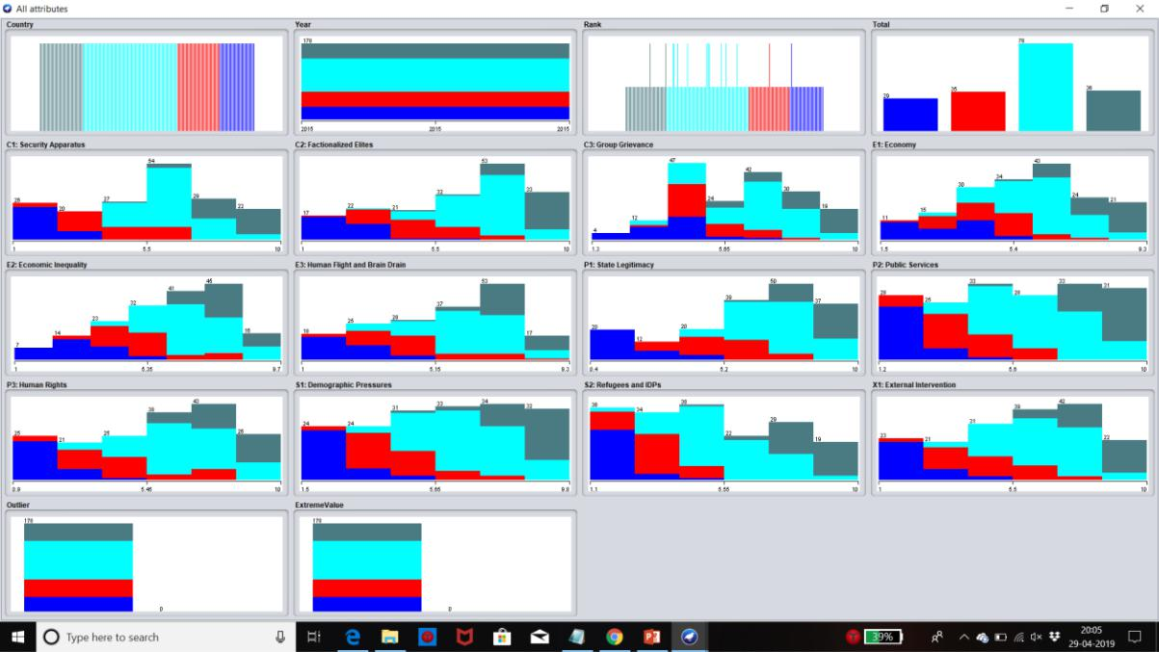

Saving this file in csv format

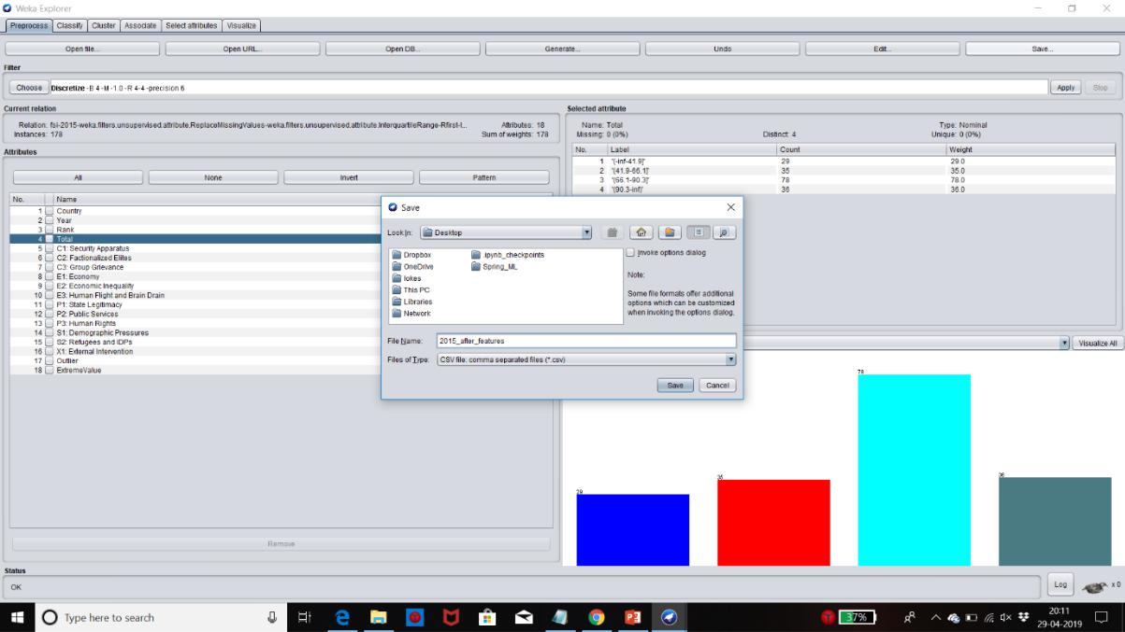

**YEAR – 2016**

**REPLACING MISSING VALUES**

Filter - ReplaceMissingValues

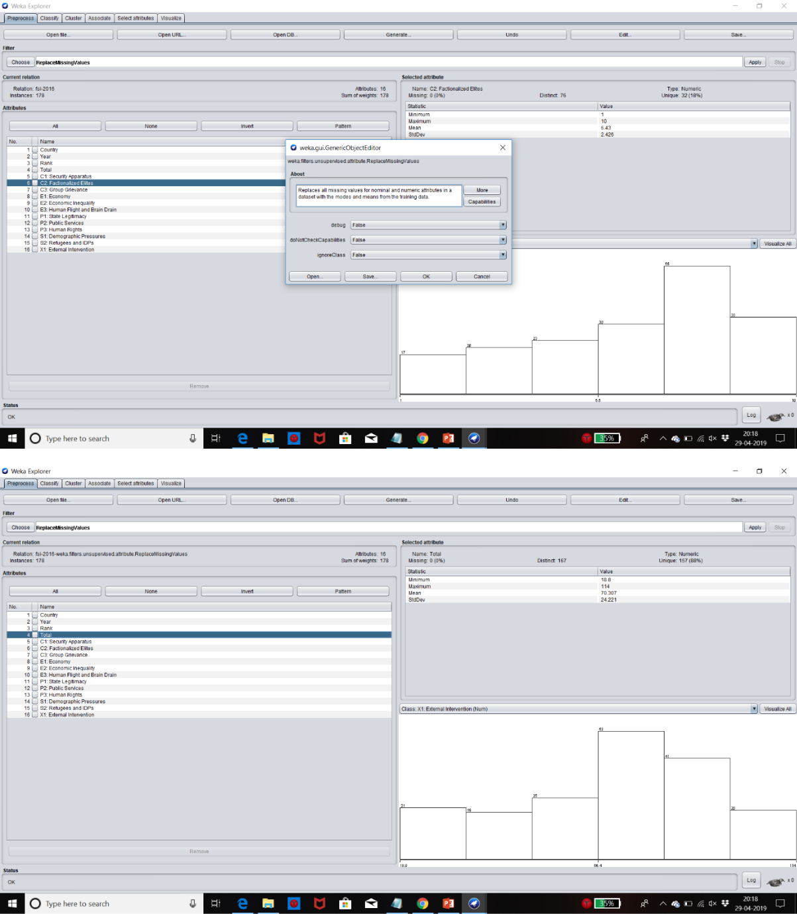

**OUTLIER REMOVAL**

Filter - Interquartile Range

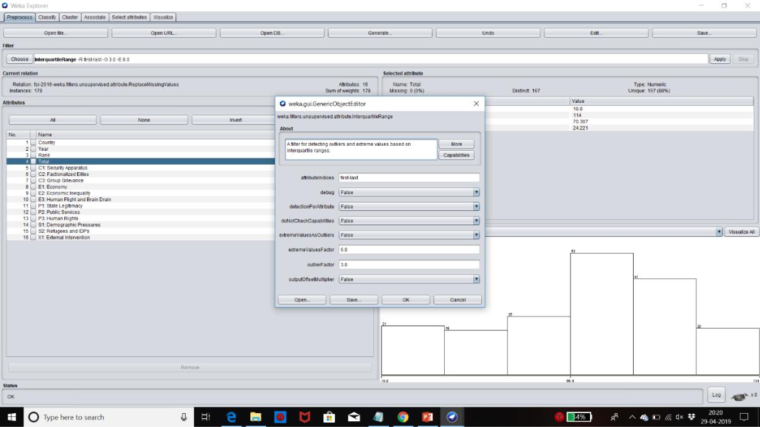

**DISCRETIZATION**

Filter used - Discretize

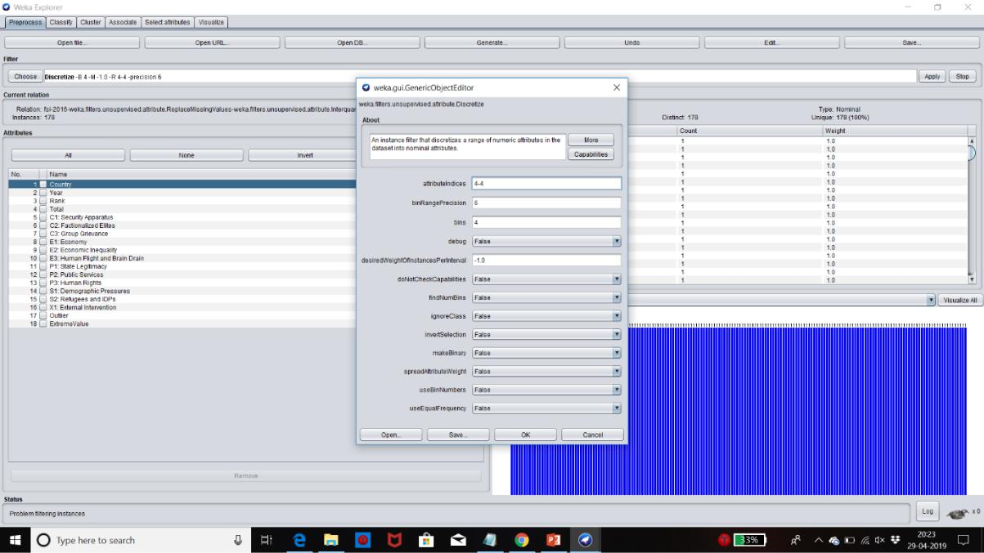

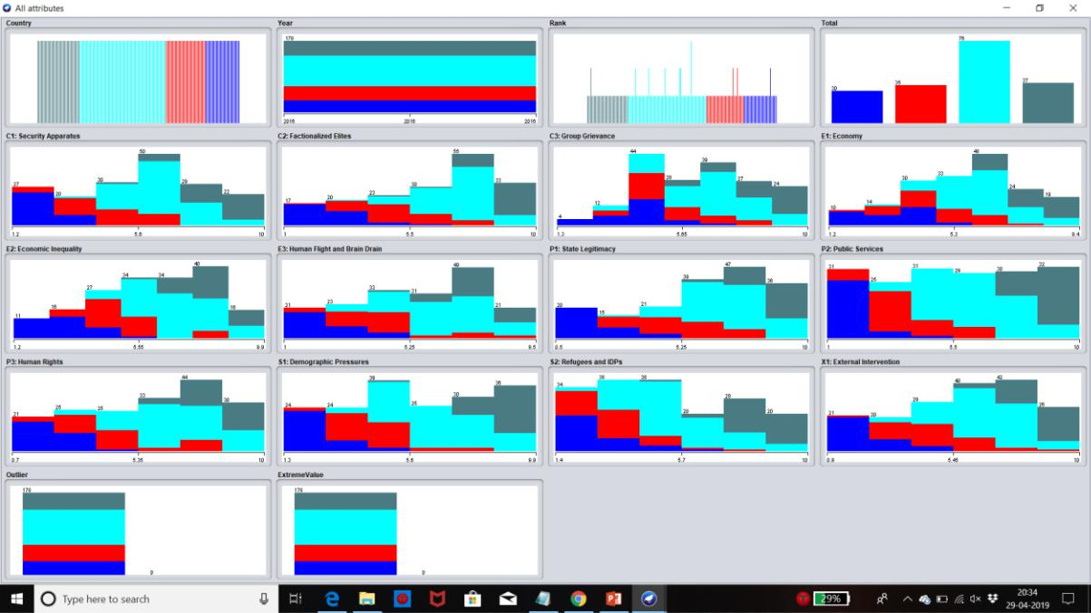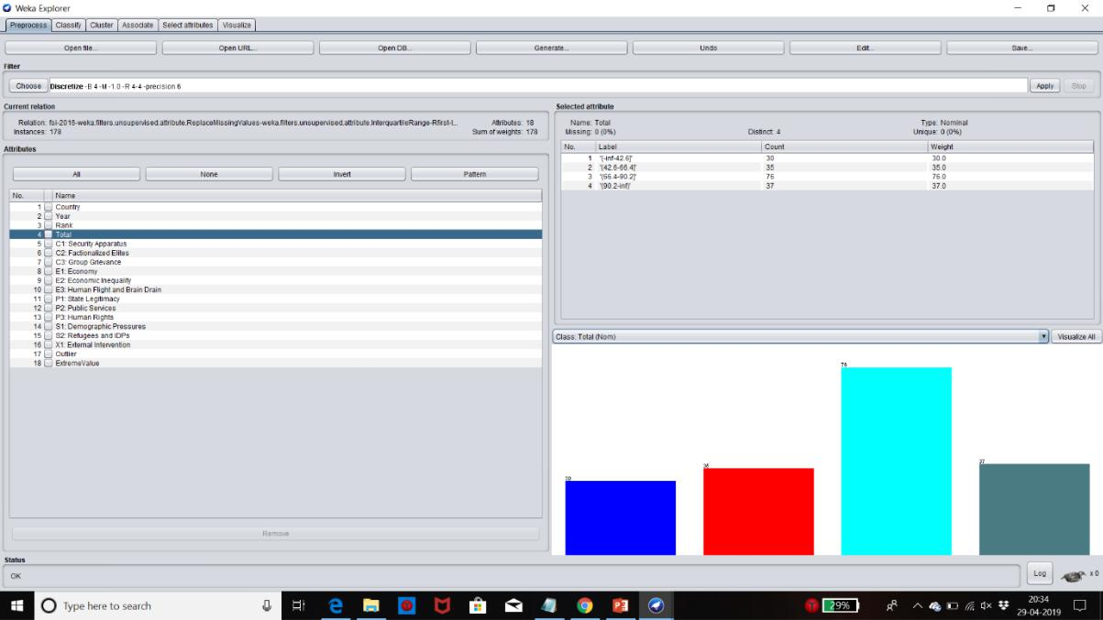

Saving this file in csv format

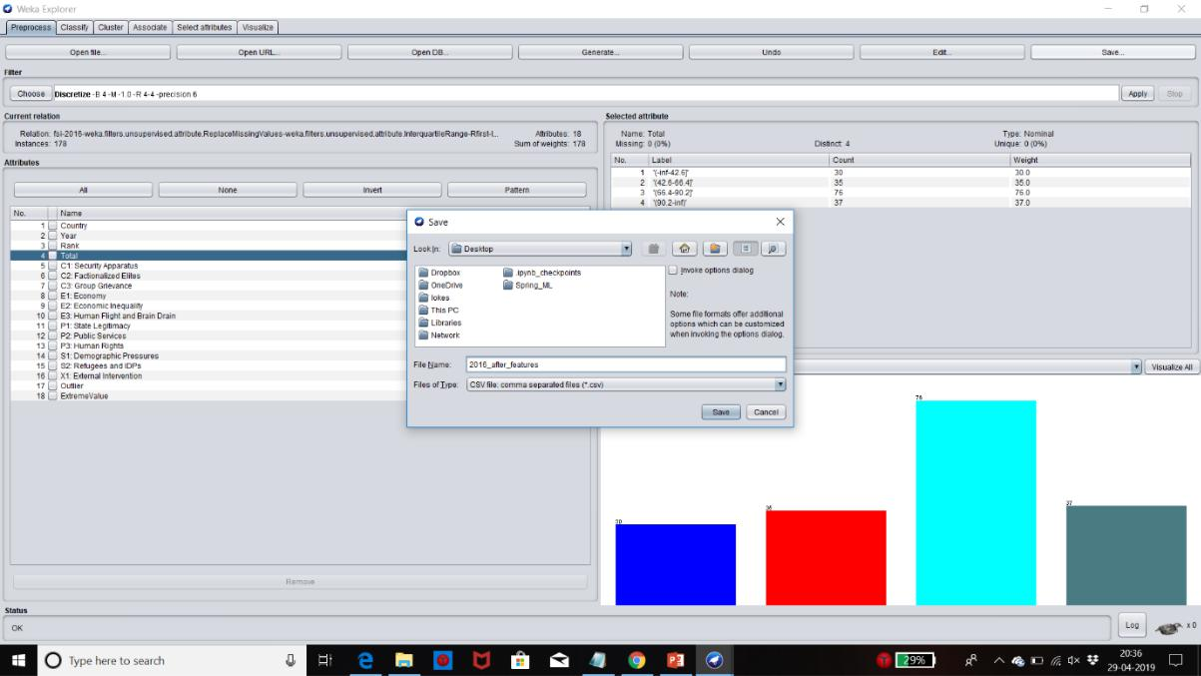

**DATA CLASSIFICATION**

For Classification, we have used the following classifiers. Each classifier is made to run for the dataset from the year 2014 to 2016.

Also, we have calculated the accuracy for each classifier for the datasets before adding the extra-features and after adding the extra-features to compare the efficiency of both types of datasets.

The different classifiers are as follows

* BayesNet
* Naïve Bayes
* J48

**BayesNet**

Bayes Network uses different search algorithms and metrics of performance. The Base Class for a Bayes Network Classifier includes popular Bayes Network algorithms such as K2 and B data structures and facilities.

**Naïve Bayes**

Class for a Naive Bayes classifier uses estimator classes. Numeric estimator precision values are chosen based on an analysis of the training data. The Naïve

Bayes Updateable classifier will use a default precision of 0.1 for numeric attributes when built, Classifier is called with zero training instances.

**J48**

The C4.5 algorithm for building decision trees is implemented in Weka as a classifier called J48. Class for generating a pruned or unpruned C4.5 decision tree

**CLASSIFICATION – 2014 BEFORE ADDING EXTRA FEATURES**

**BAYESNET**

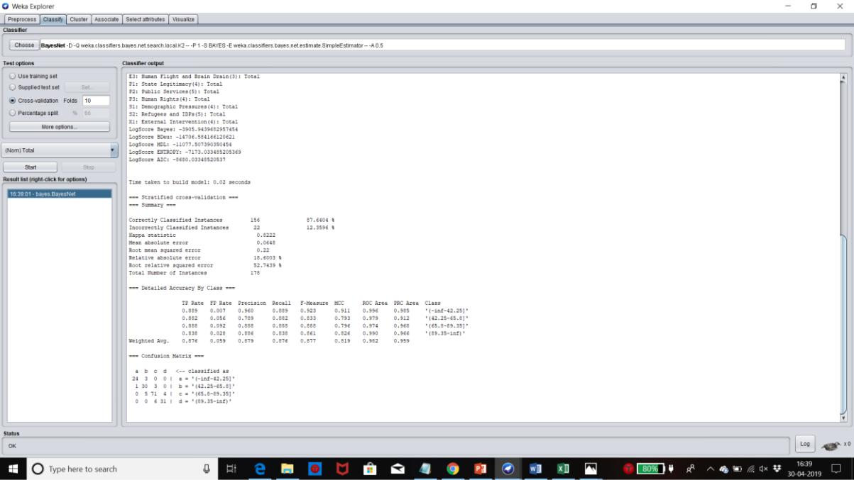

**NAÏVE BAYES**

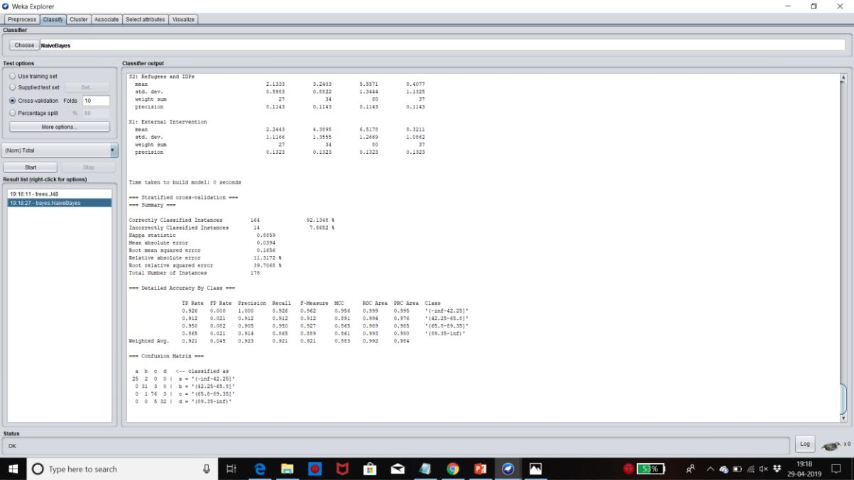

**J48**

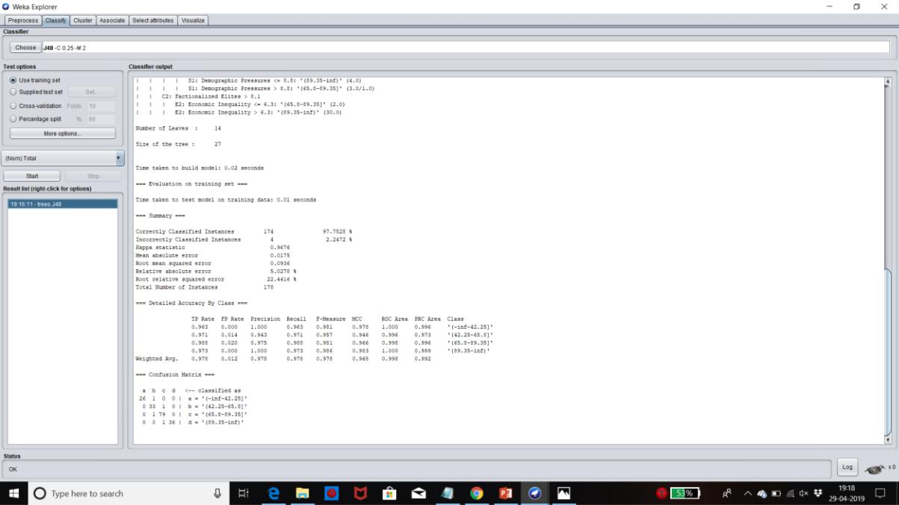

**CLASSIFICATION 2014 – AFTER ADDING EXTRA FEATURES**

**BAYESNET**

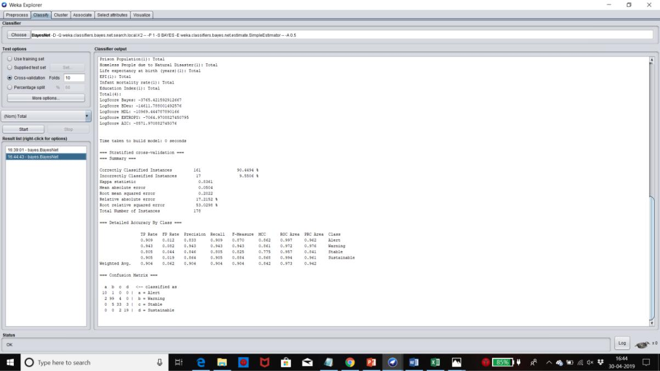

**NAÏVE BAYES**

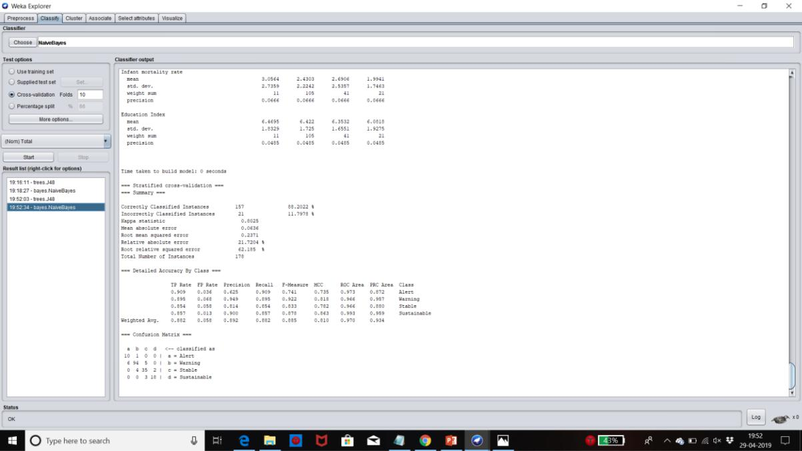

**J48**

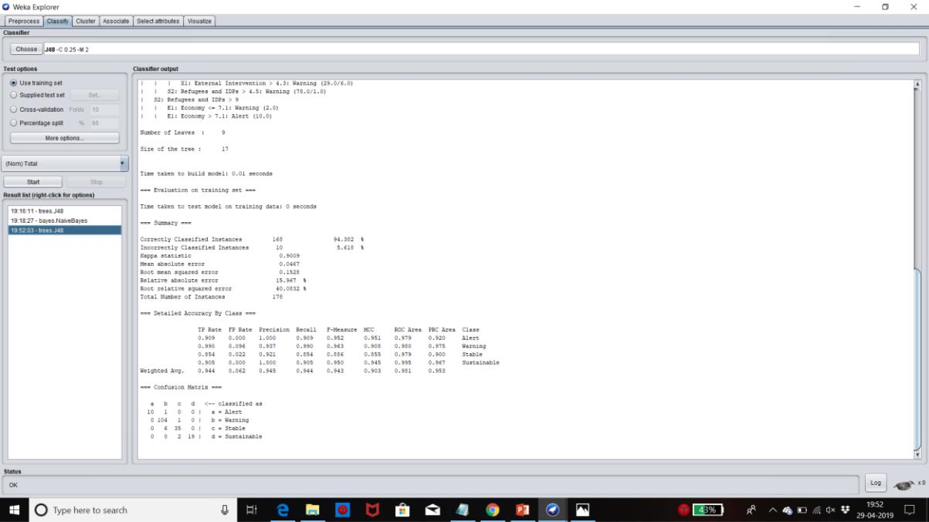

**CLASSIFICATION 2015 – BEFORE ADDING EXTRA FEATURES**

**BAYESNET**

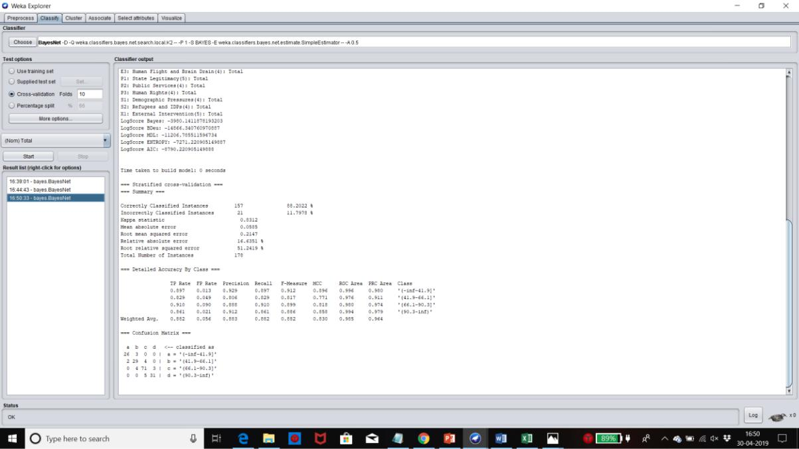

**NAÏVE BAYES**

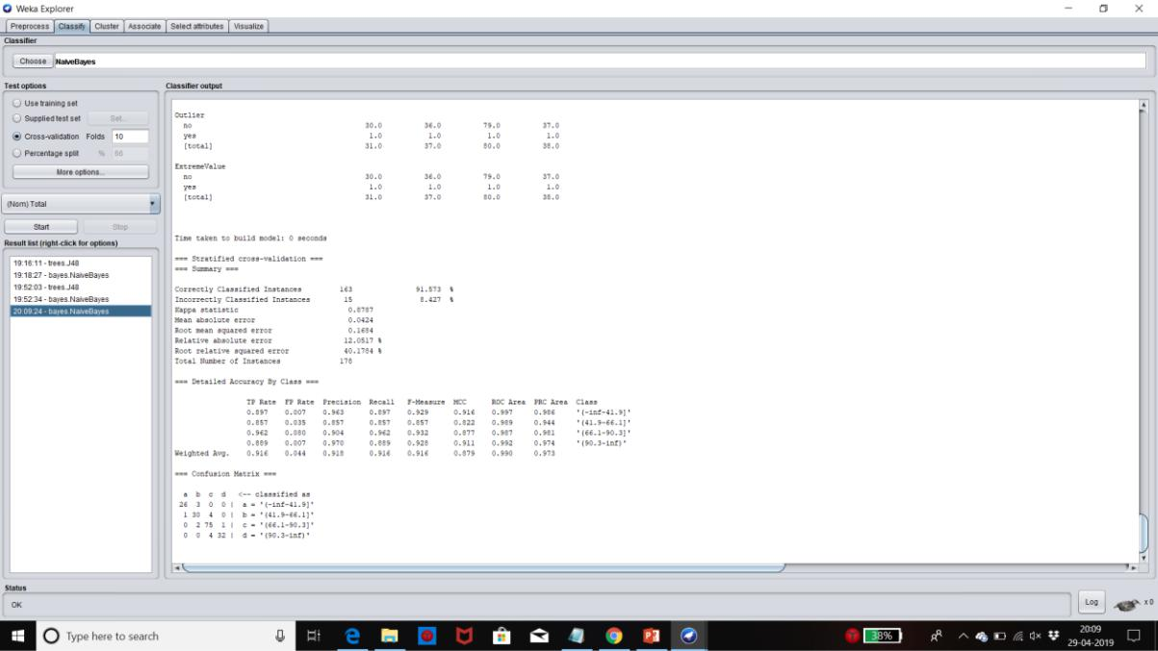

**J48**

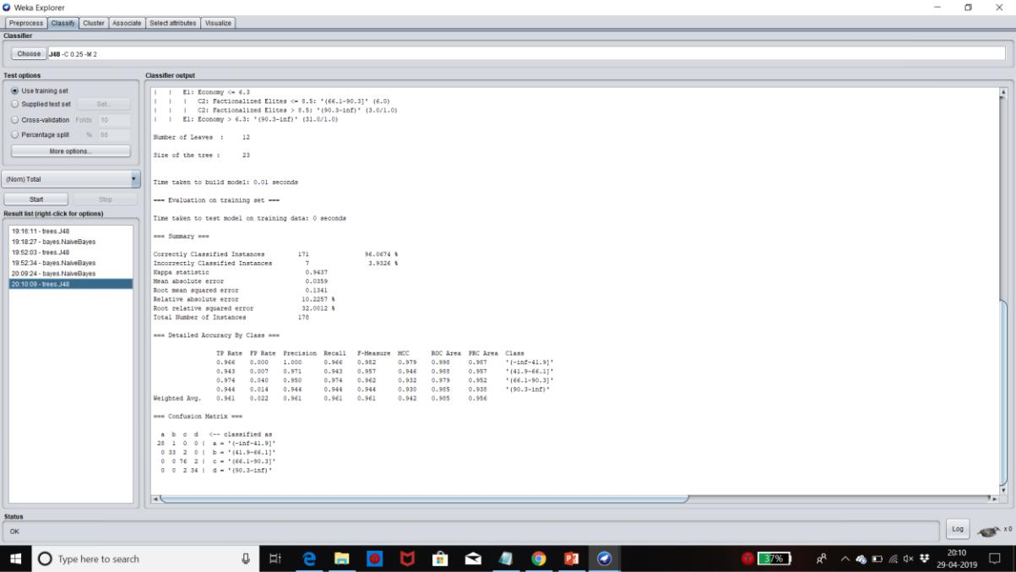

**CLASSIFICATION 2015 – AFTER ADDING EXTRA FEATURES**

**BAYESNET**

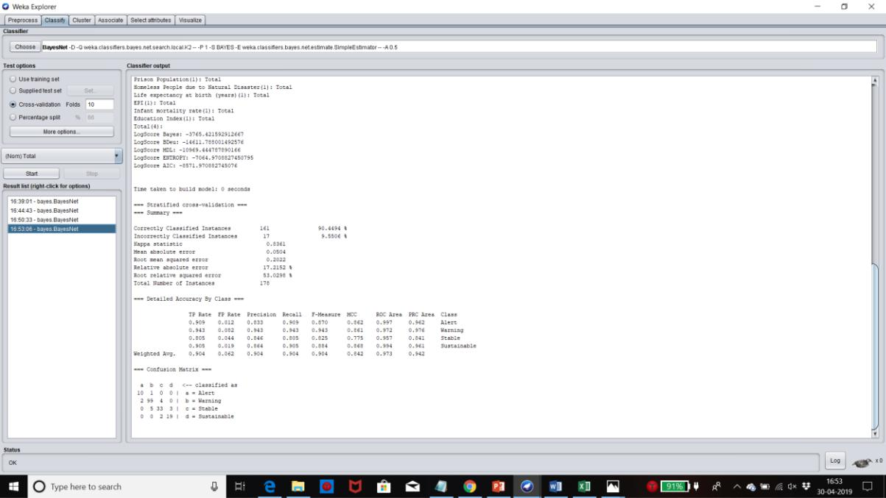

**NAÏVE BAYES**

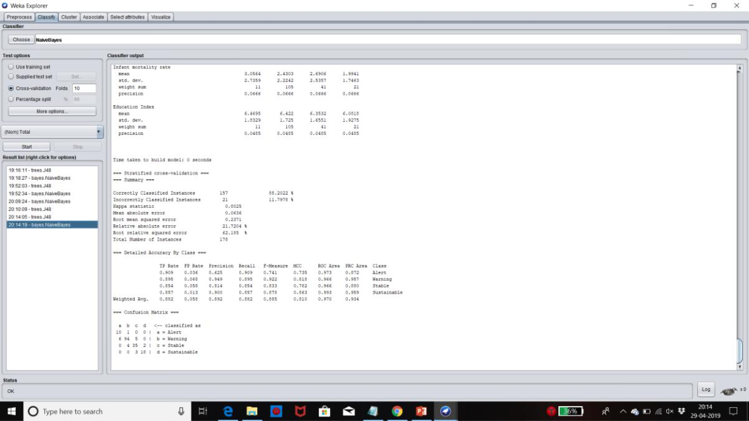

**J48**

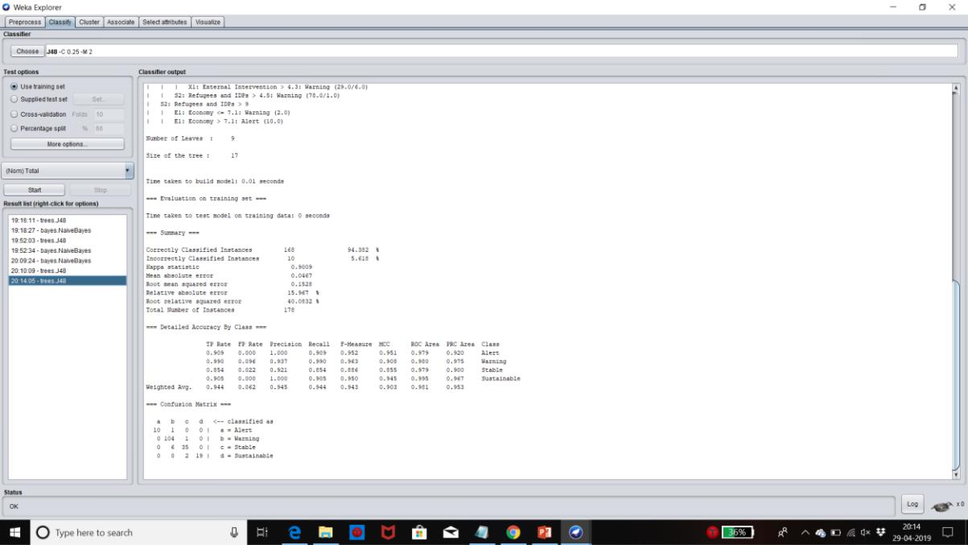

**CLASSIFICATION 2016 – BEFORE ADDING EXTRA FEATURES**

**BAYESNET**

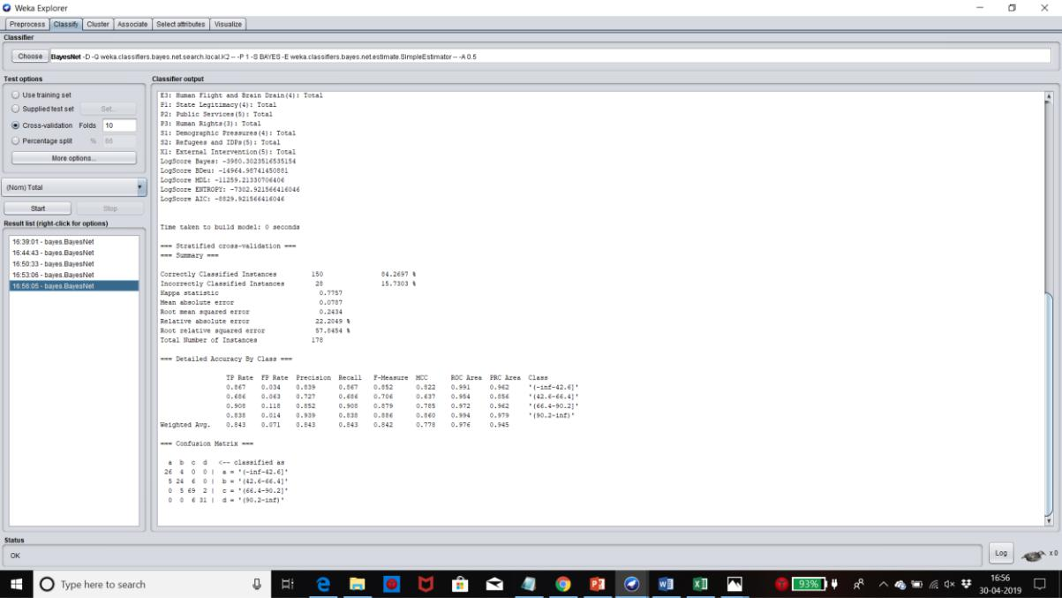

**NAÏVE BAYES**

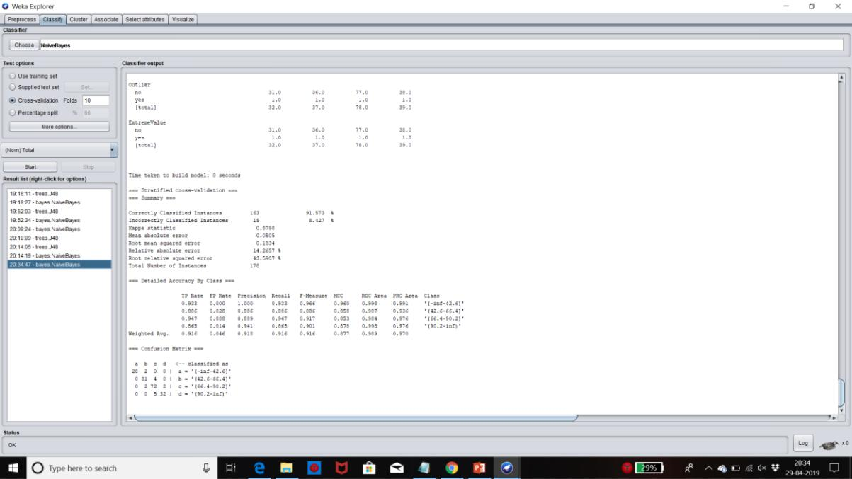

**J48**

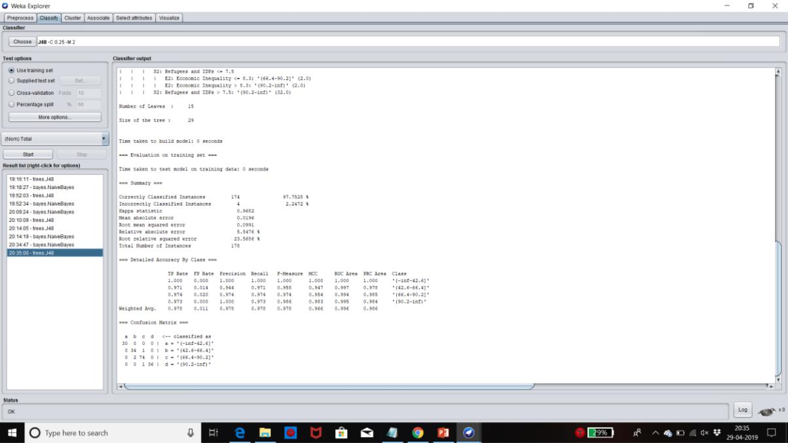

**CLASSIFICATION 2016 – AFTER ADDING EXTRA FEATURES**

**BAYESNET**

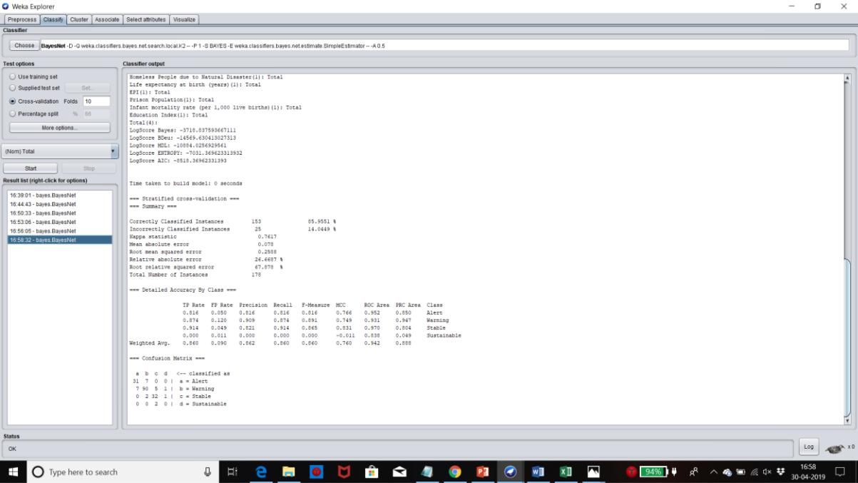

**NAÏVE BAYES**

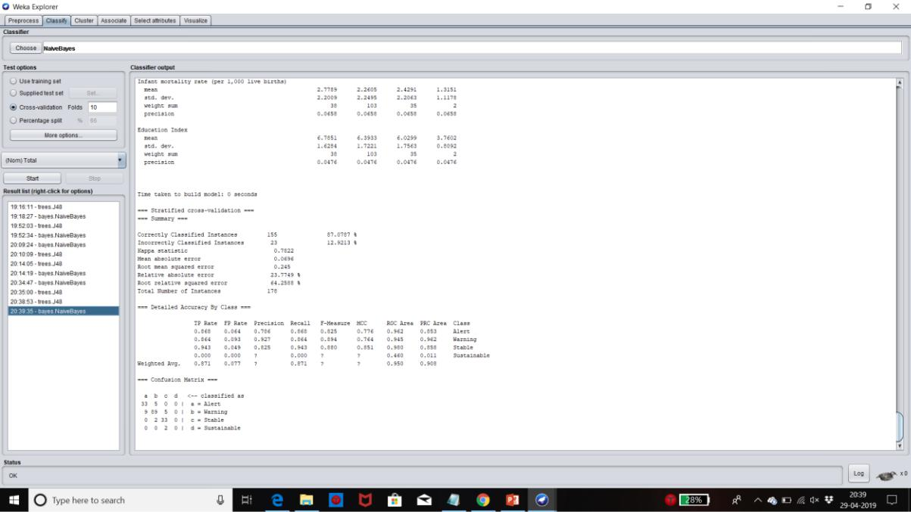

**J48**

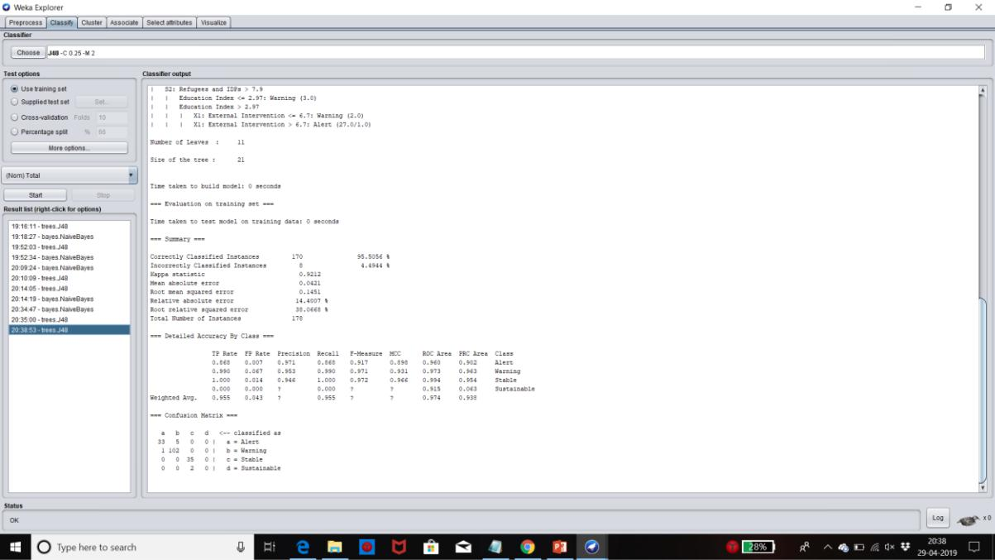

**CREATING ACTION RULES USING LISP MINER**

The attributes are classified into three categories. They are as follows.

* Stable
* Flexible
* Decision

The stable attributes are as follows.

* Country
* Rank

The flexible attributes are as follows.

* Homeless people due to natural disaster
* Public services
* Refugees and IDPs
* External intervention
* Prison Population

**ITCS 6162 KNOWLEDGE DISCOVERY IN DATABASES (KDD)**

The decision attributes are as follows.

* Alert
* Warning
* Stable
* Sustainable

Antecedent stable part - All the stable attributes are assigned to this set.

Antecedent variable part - All the flexible attributes are assigned to this set.

Succedent variable part – All the decision attributes are assigned to this set.

Attribute type - nominal

Coefficient type - one category

The Quantifiers are as follows

* a(BASE)Before - 5
* a(BASE)After - 5

**Stable attributes**

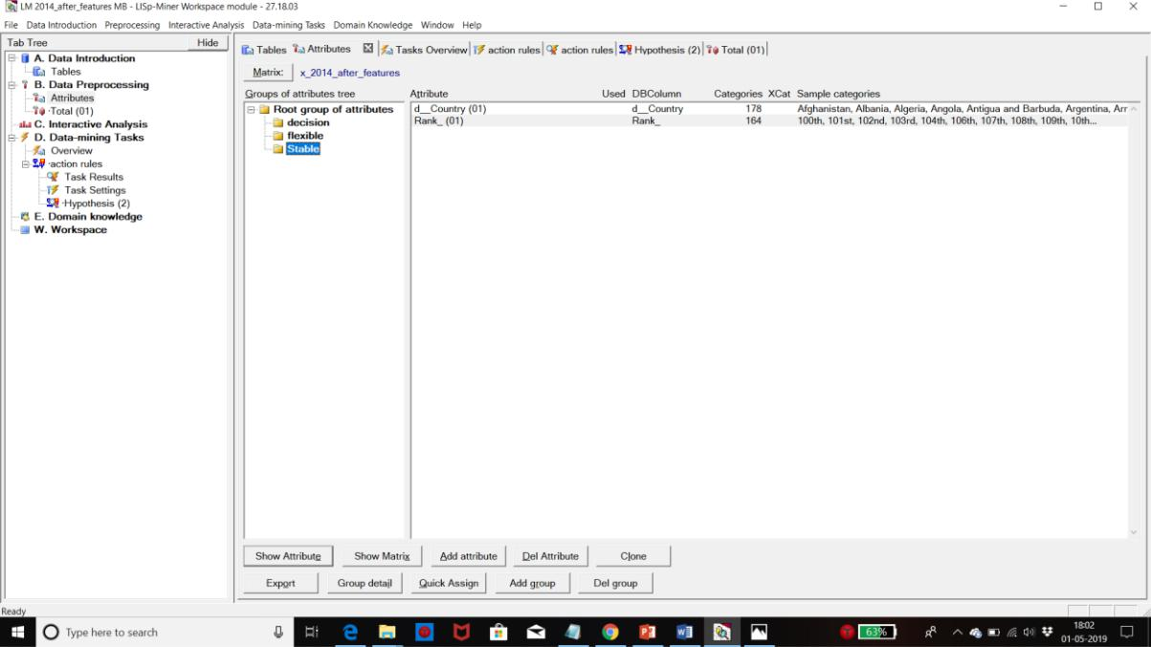

**Flexible attributes**

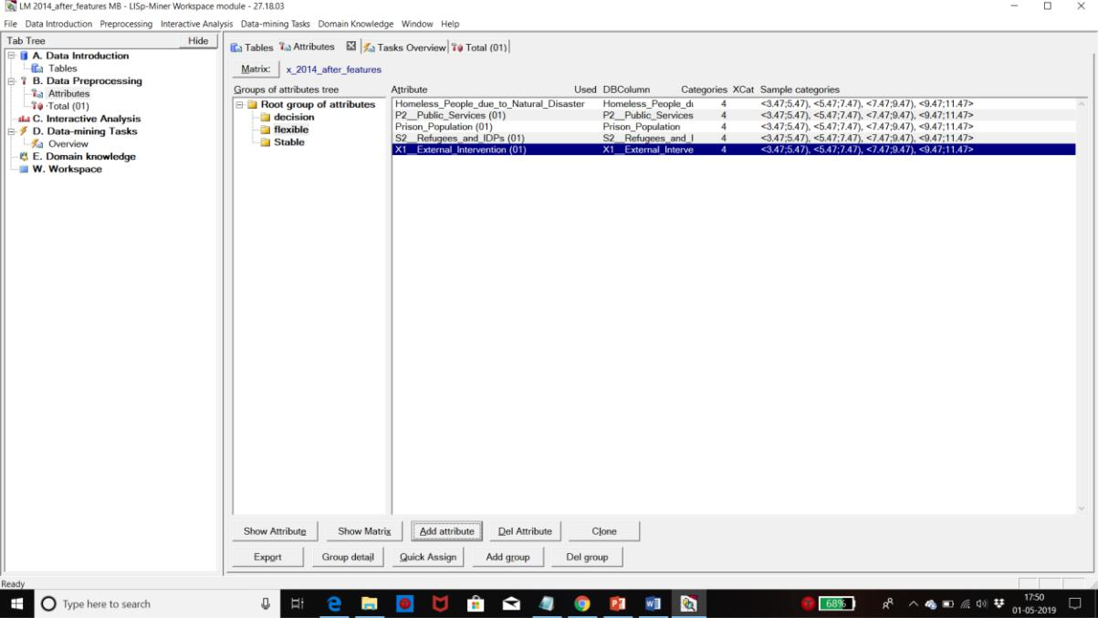

**Decision attributes**

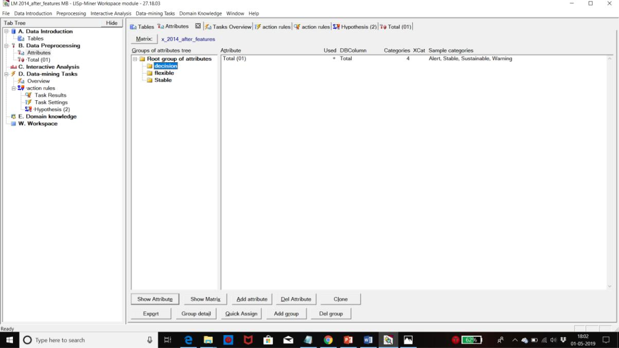

**ITCS 6162 KNOWLEDGE DISCOVERY IN DATABASES (KDD)**

**Action Rule**

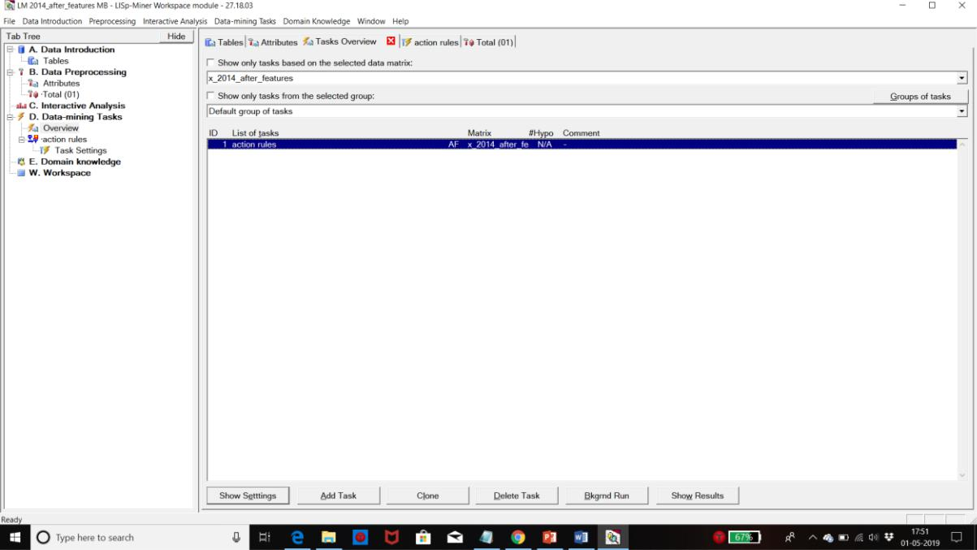

**ACTION RULES FOR 2014**

**Alert to Sustainable**

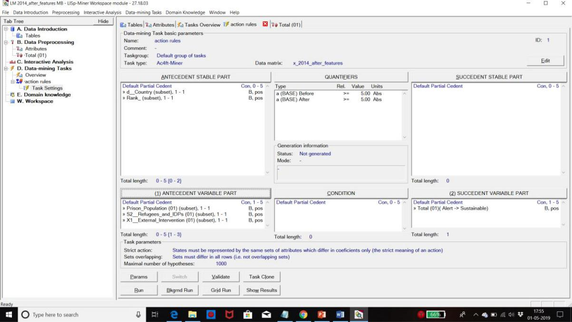

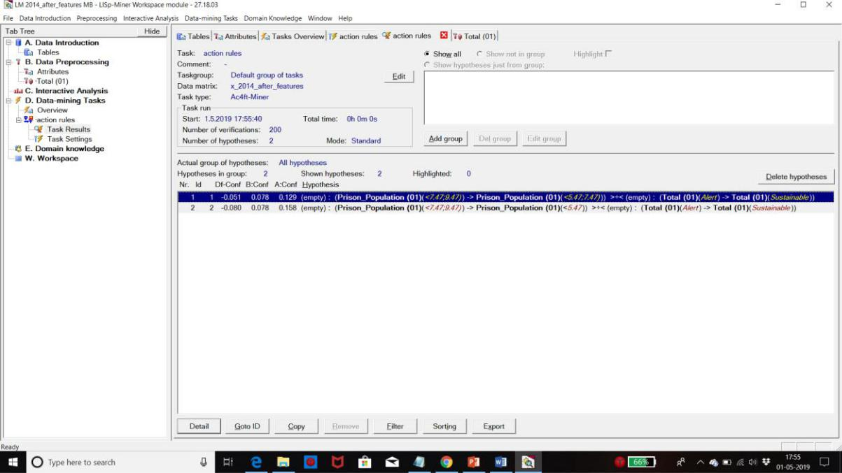

**Rule**

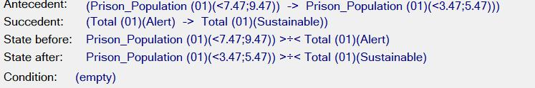

**Text**

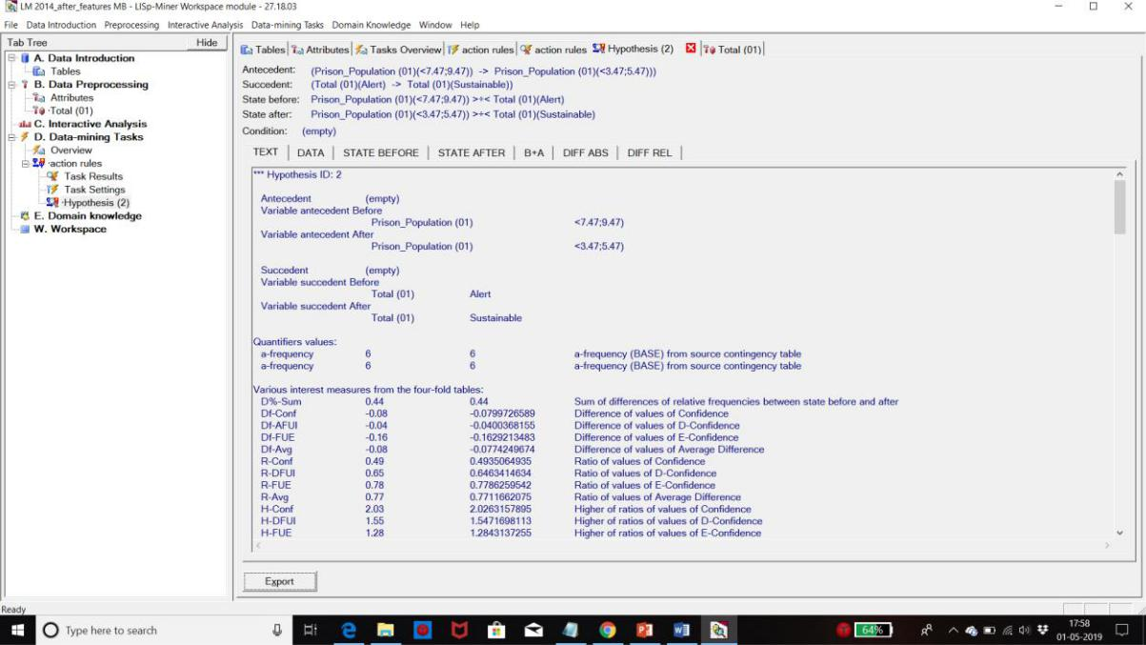

**ITCS 6162 KNOWLEDGE DISCOVERY IN DATABASES (KDD)**

**Data**

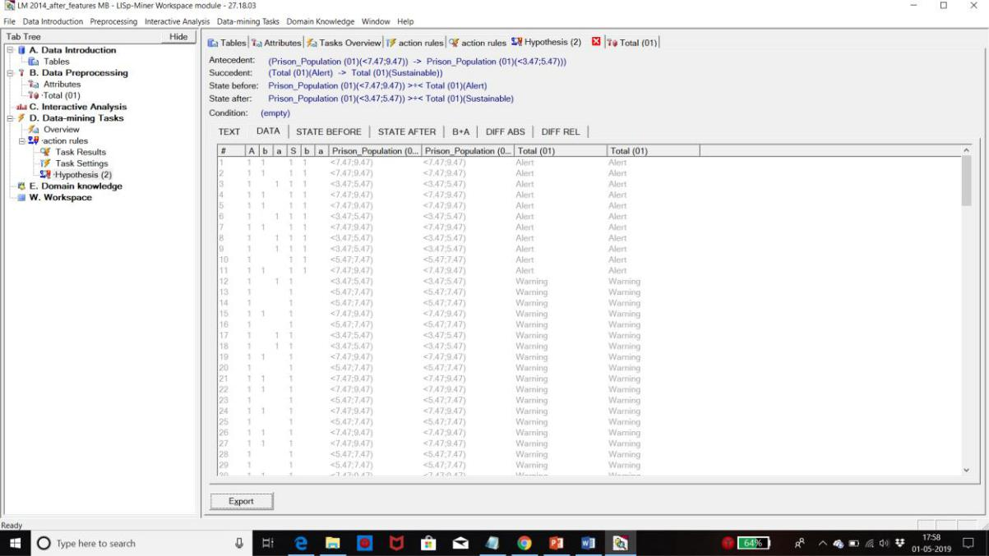

**State Before**

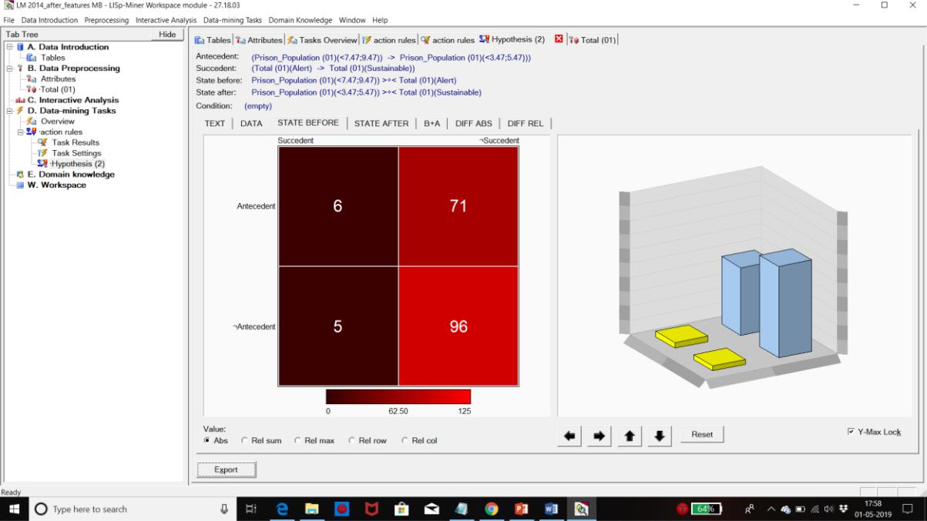

**State After**

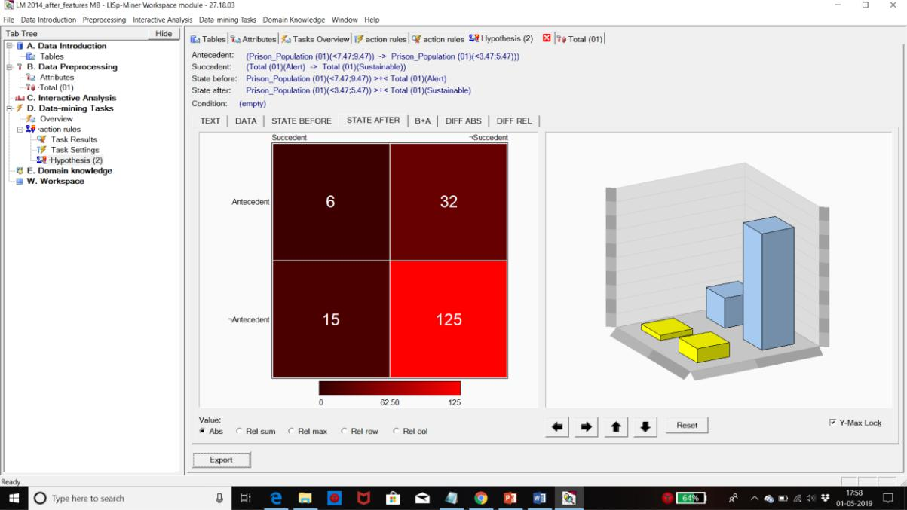

**B + A**

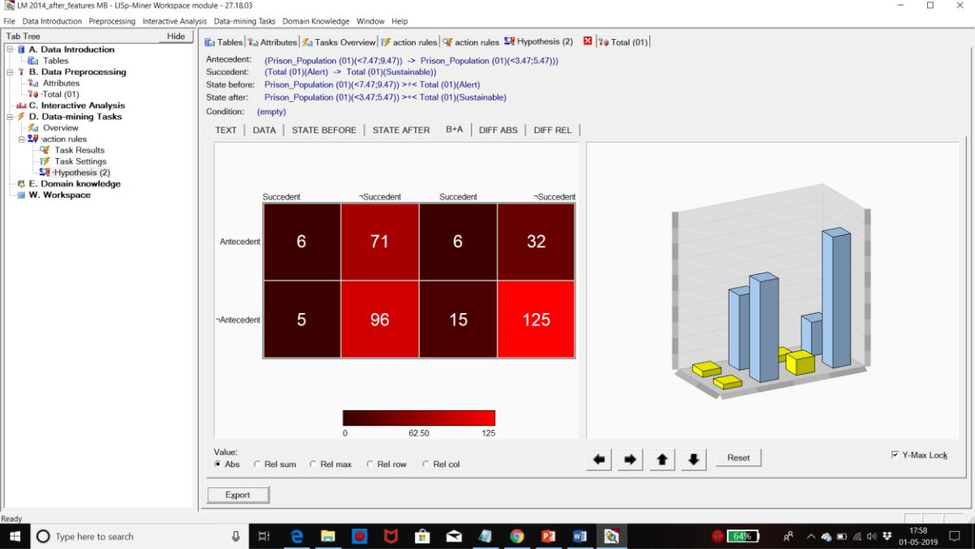

**Diff ABS**

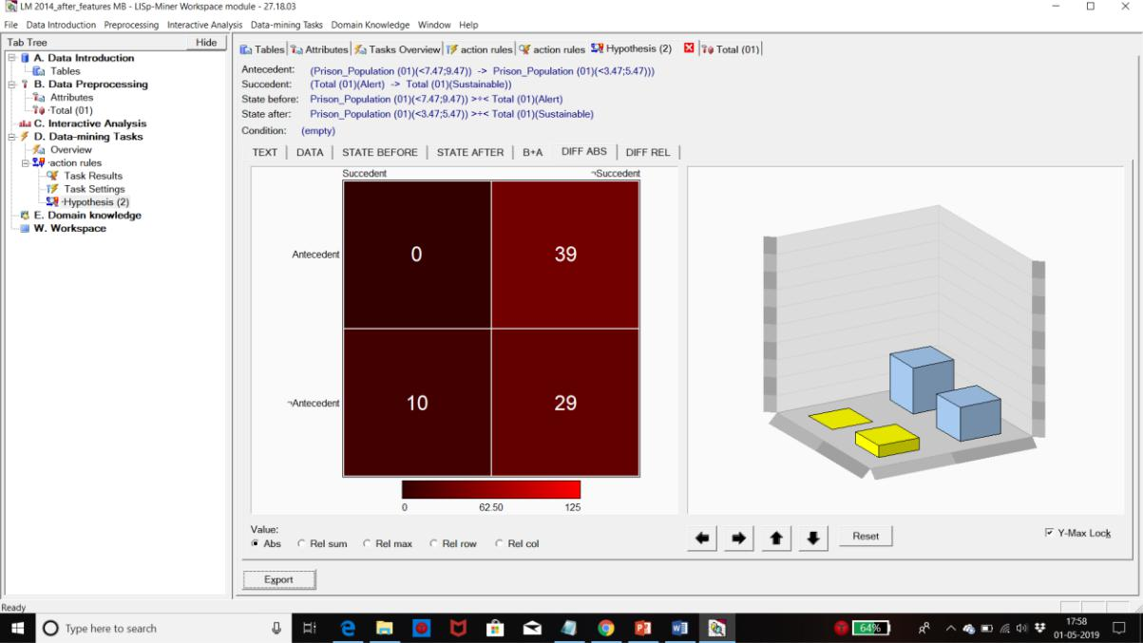

**Diff REL**

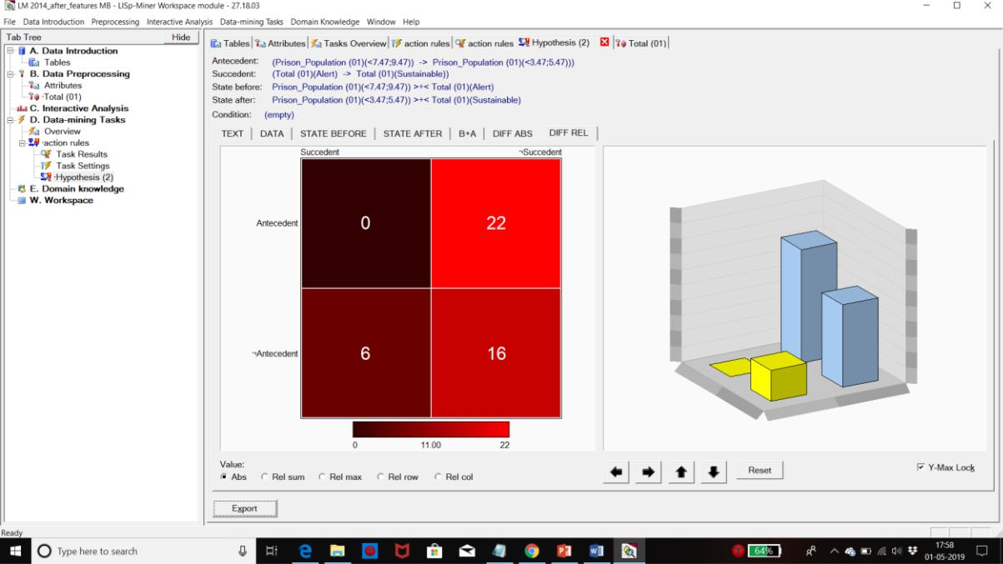

**Alert to Stable**

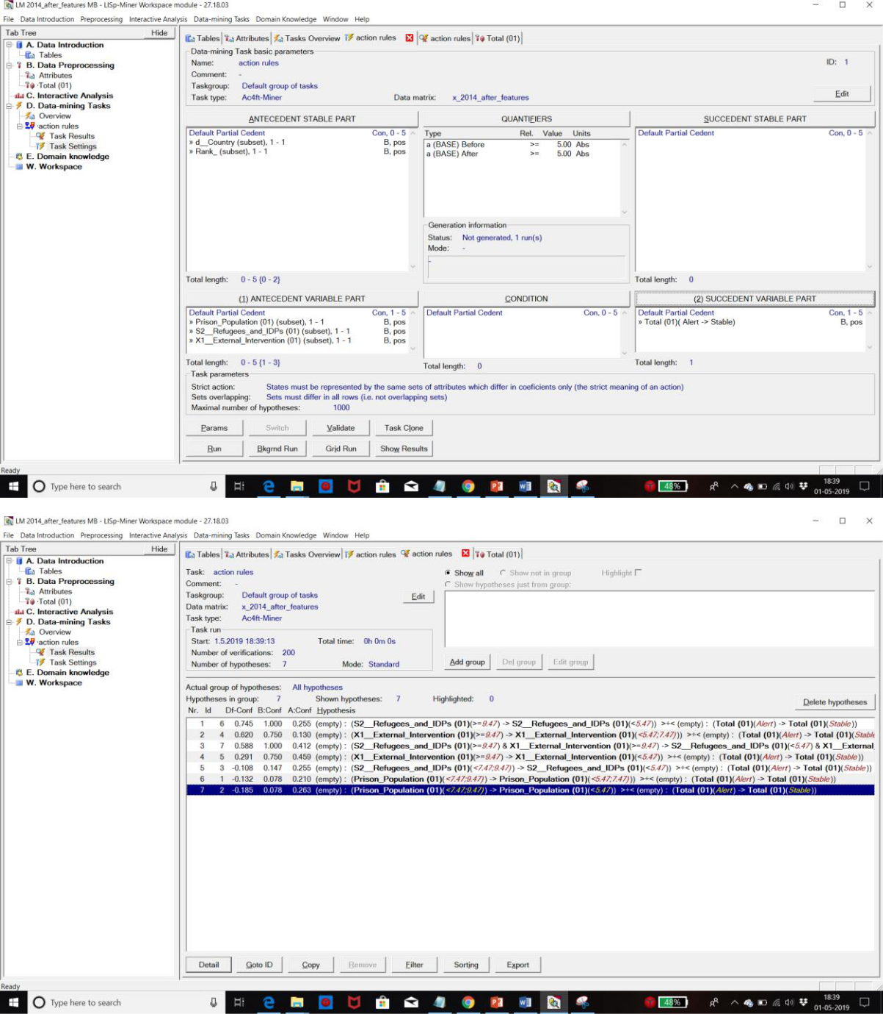



**Rule**

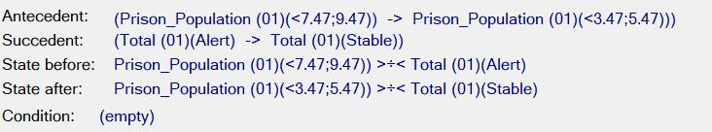

**Text**

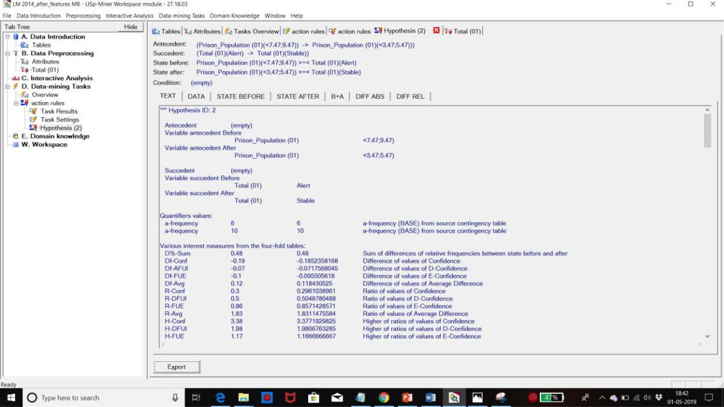

**Data**

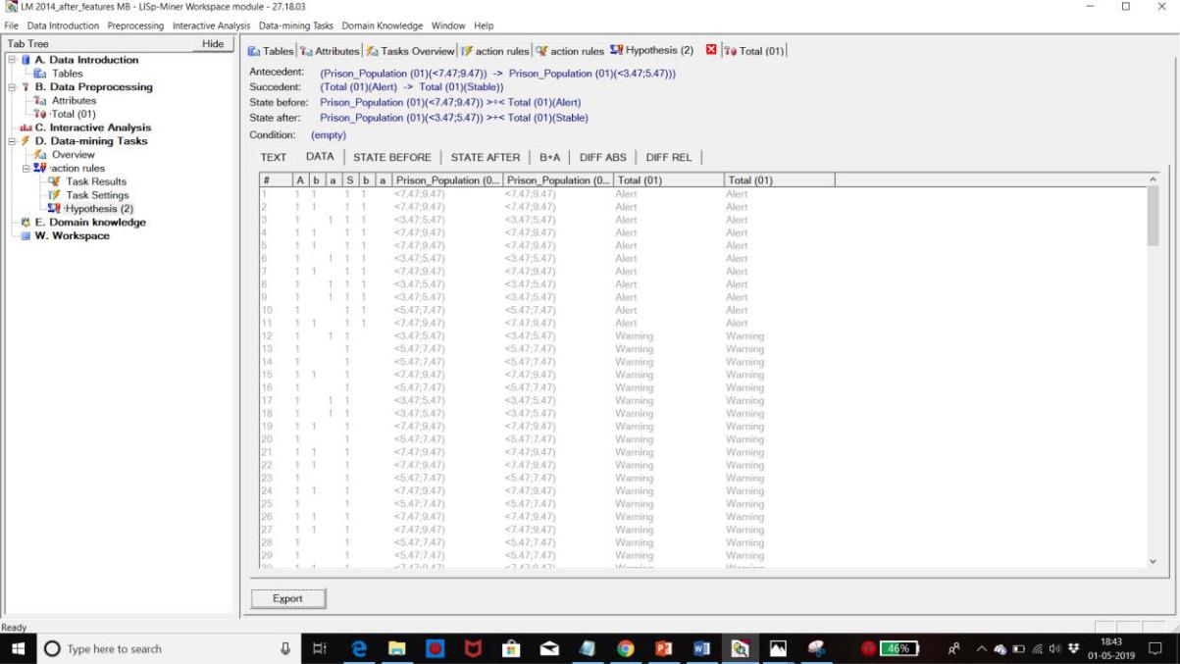

**State Before**

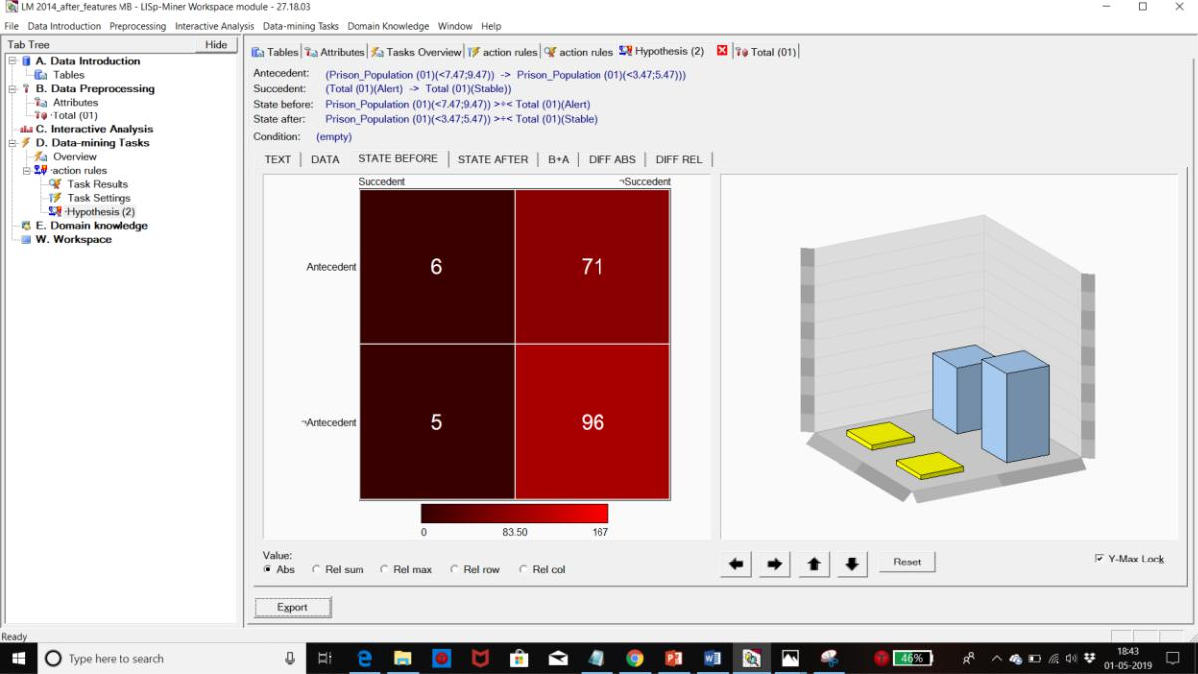

**State After**

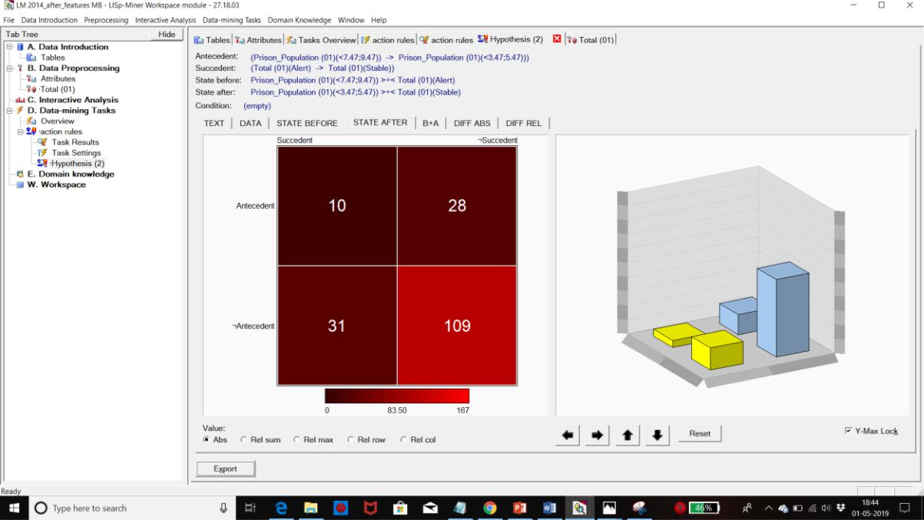

**B + A**

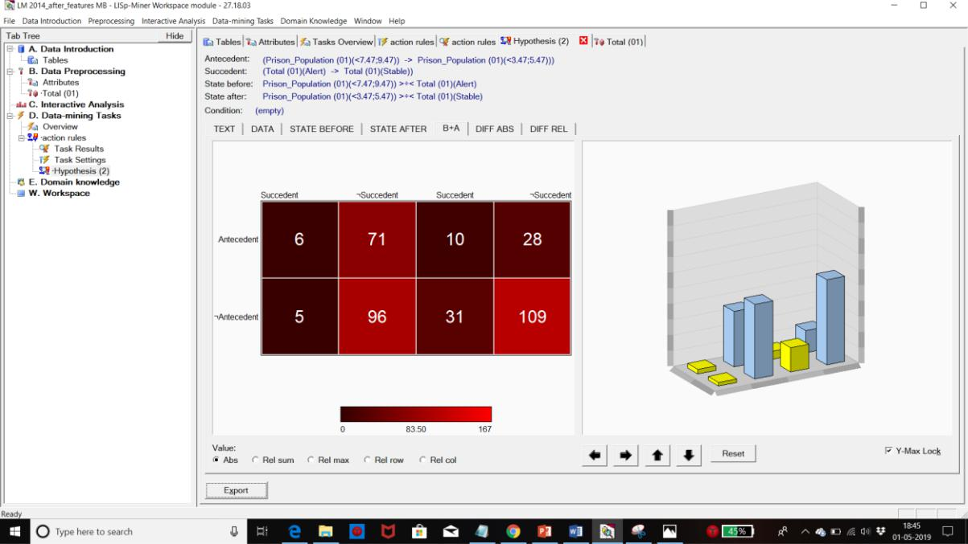

**Diff ABS**

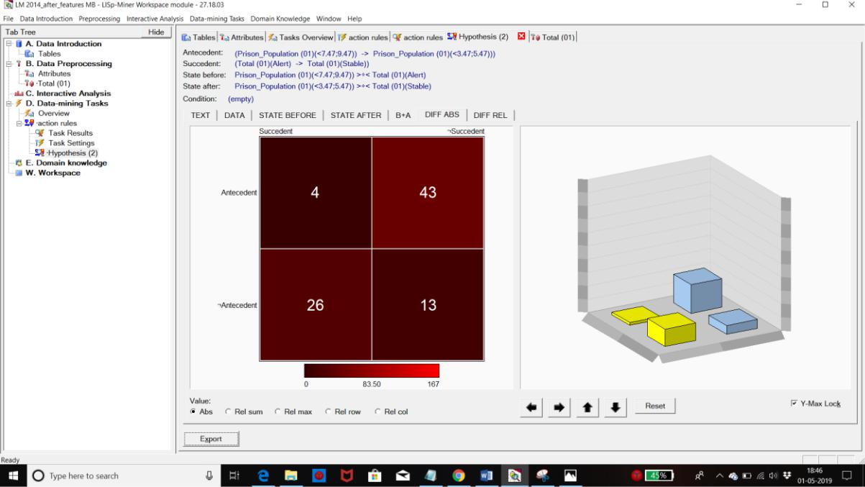

**Diff REL**

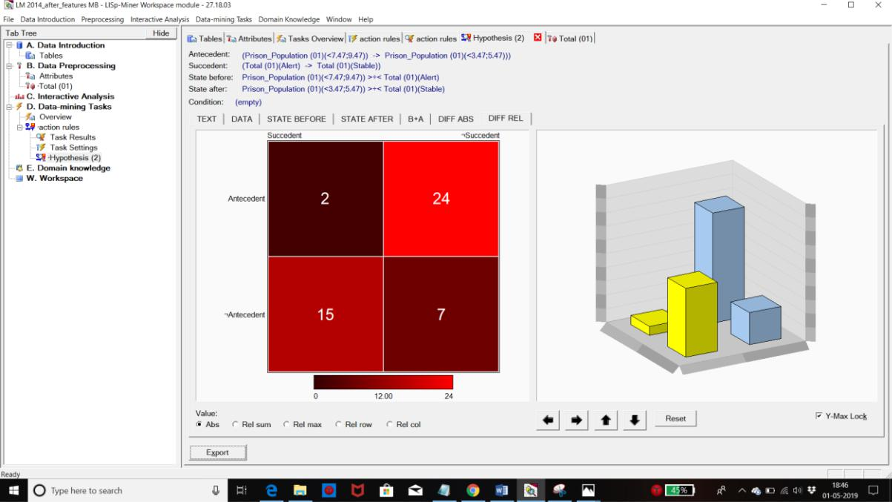

**Stable to Sustainable**

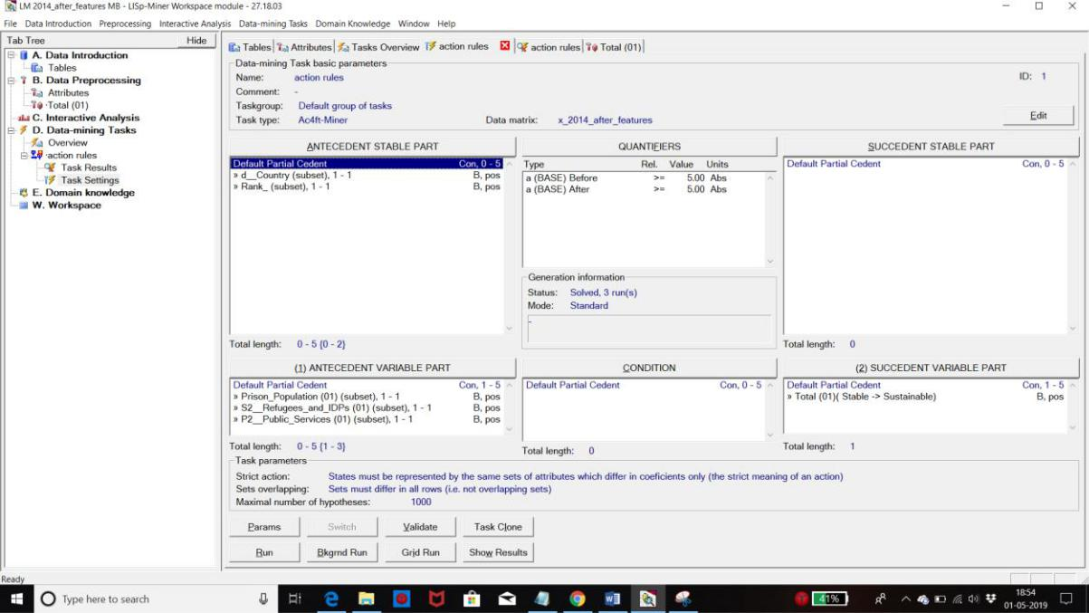

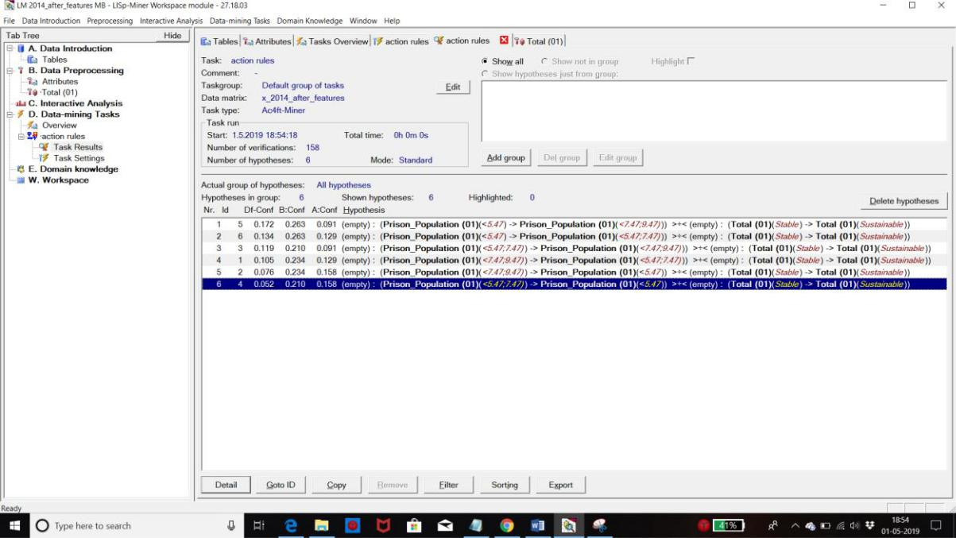

**Rule**

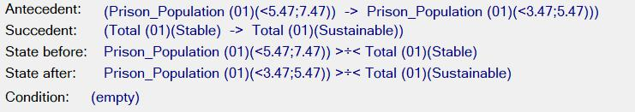

**Text**

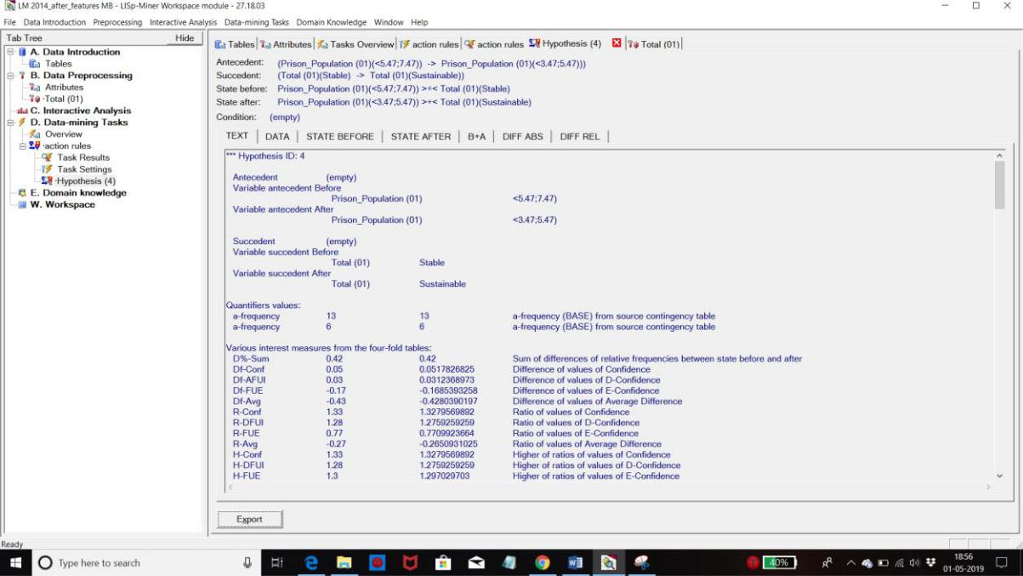

**Data**

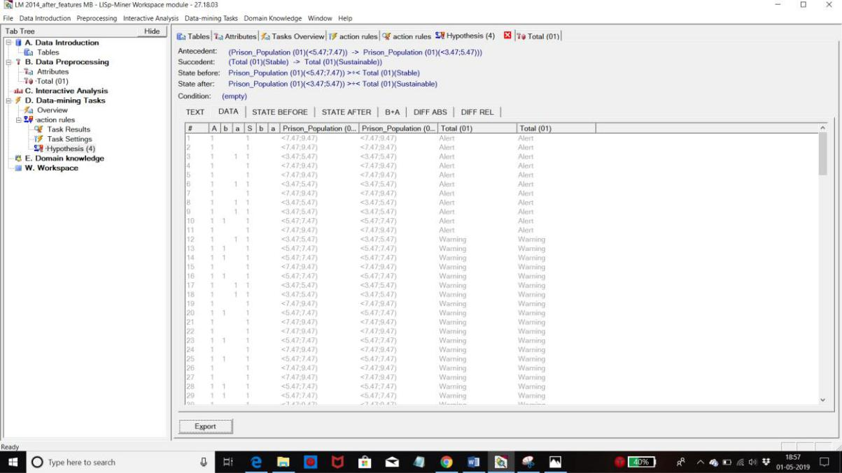

**State Before**

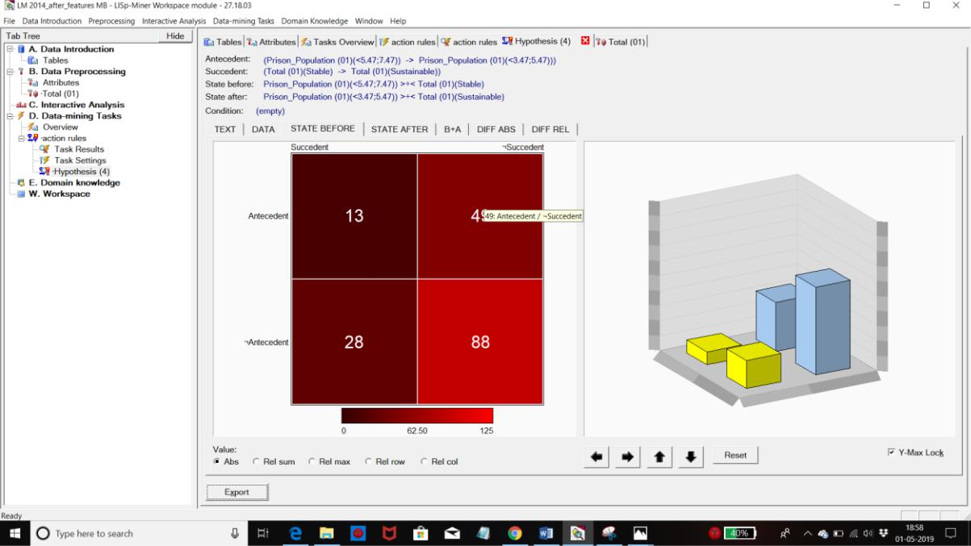

**State After**

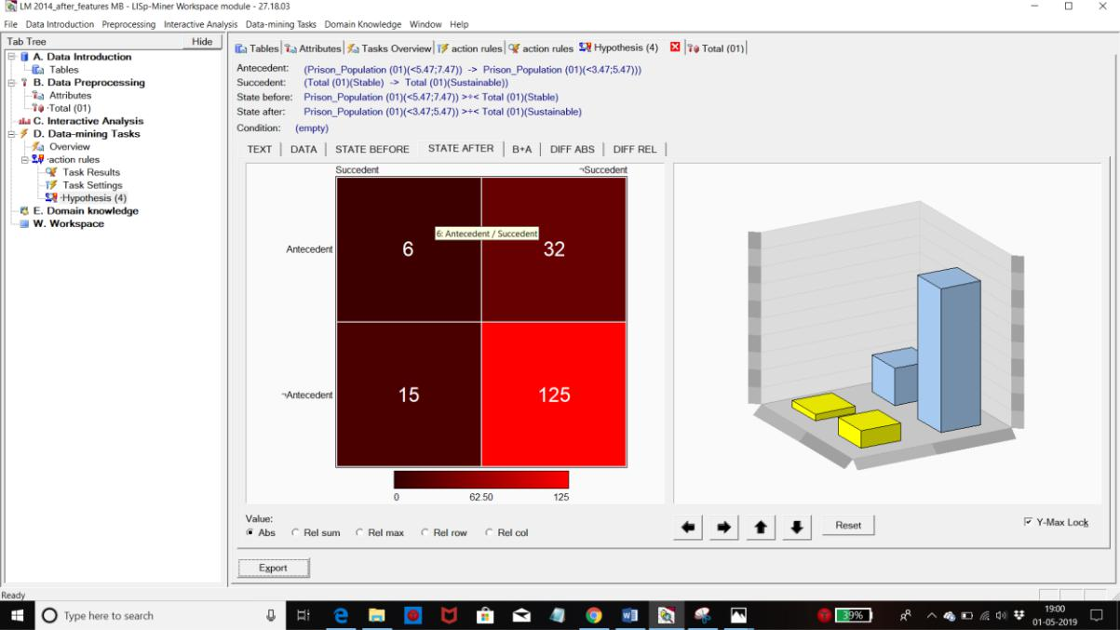

**B + A**

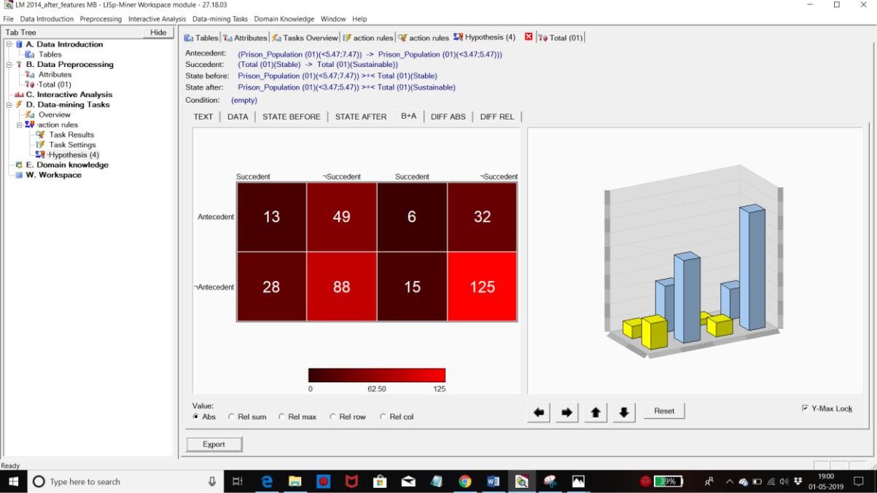

**Diff ABS**

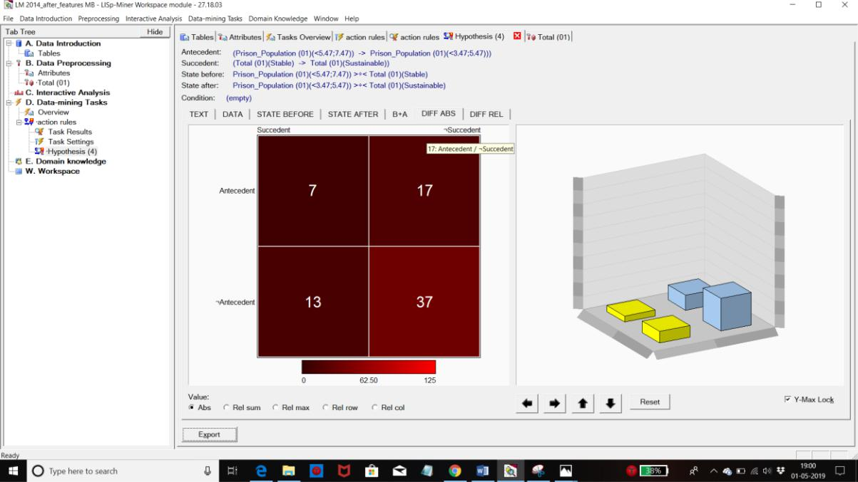

**Diff REL**

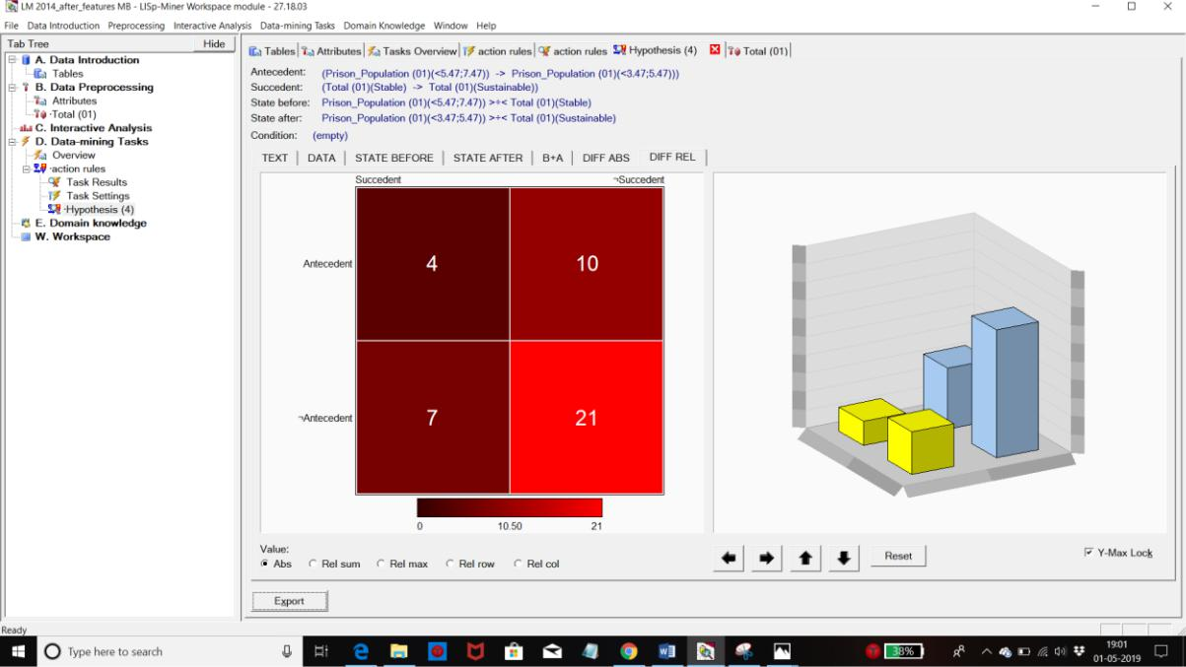

**ACTION RULES for 2015**

**Alert to Sustainable**

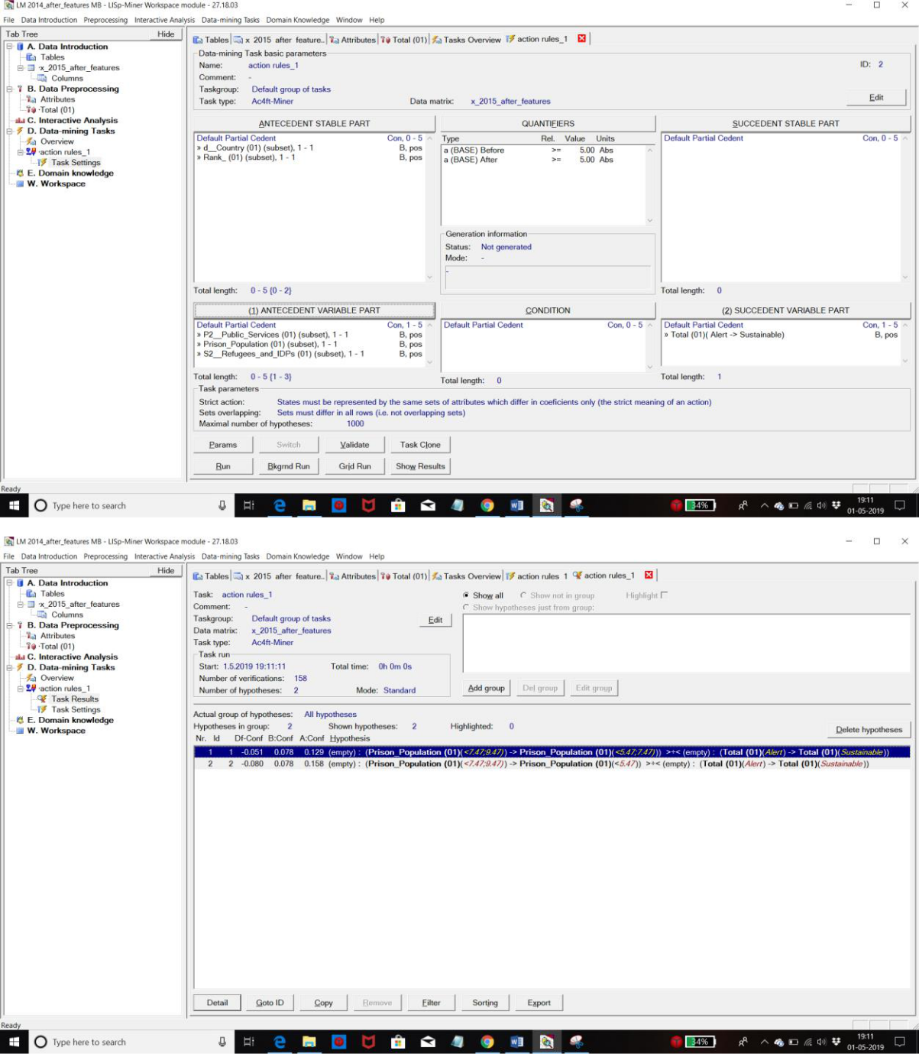



**Rule**

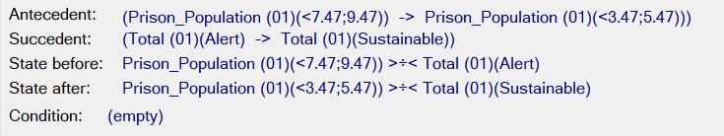

**Text**

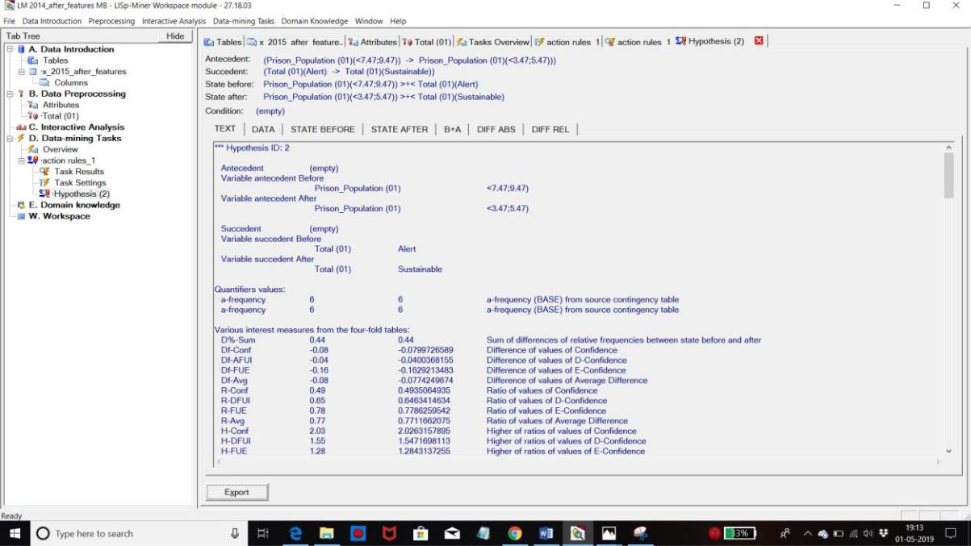

**Data**

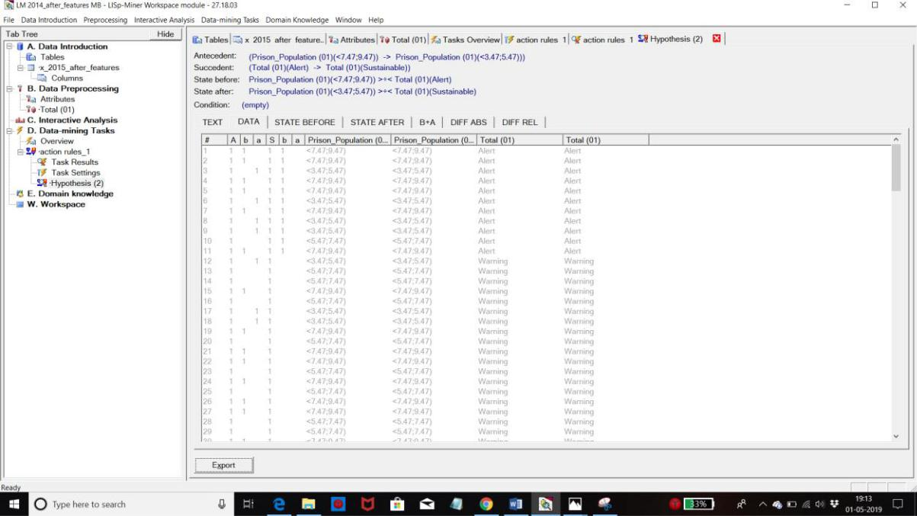

**State Before**

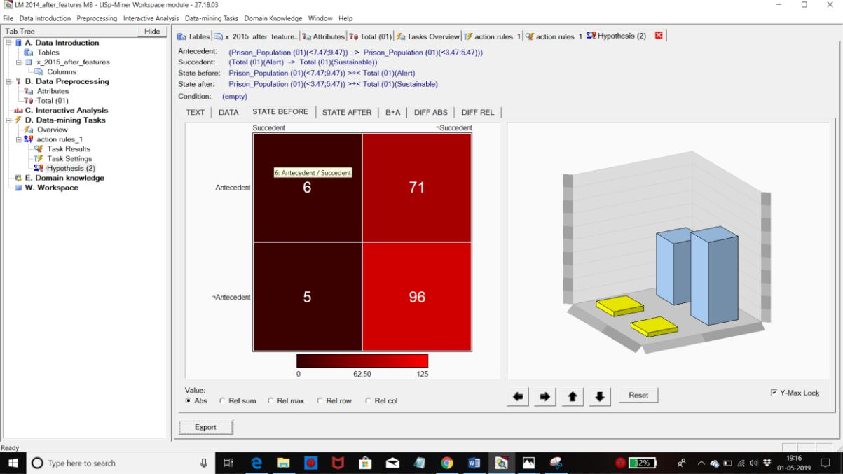

**State After**

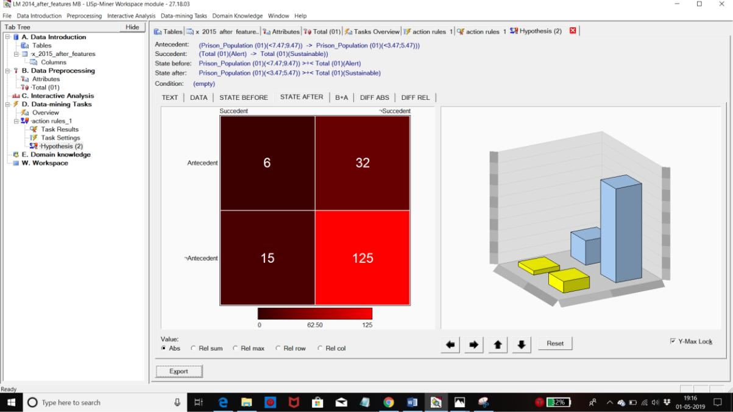

**B + A**

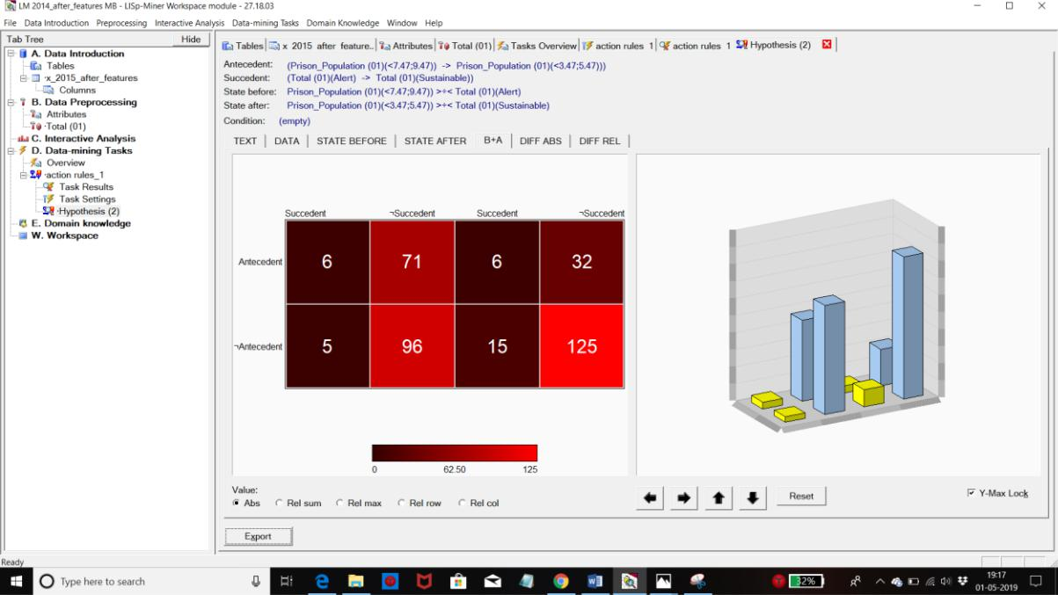

**Diff ABS**

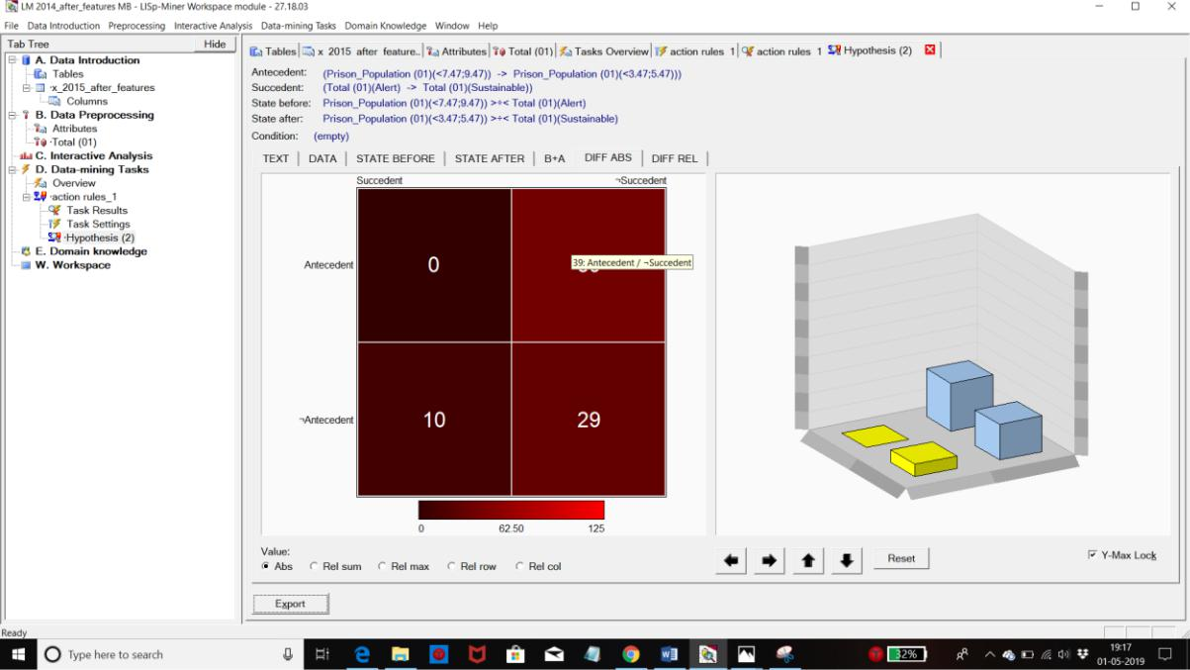

**Diff REL**

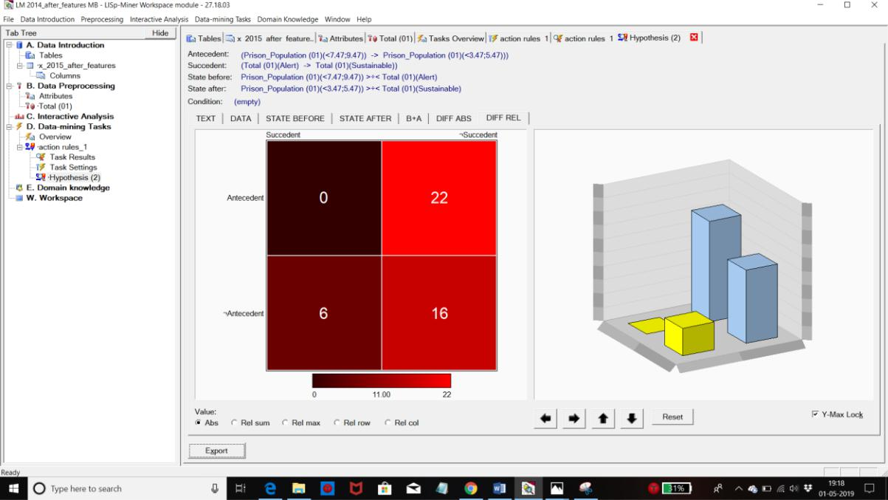

**Alert to Stable**

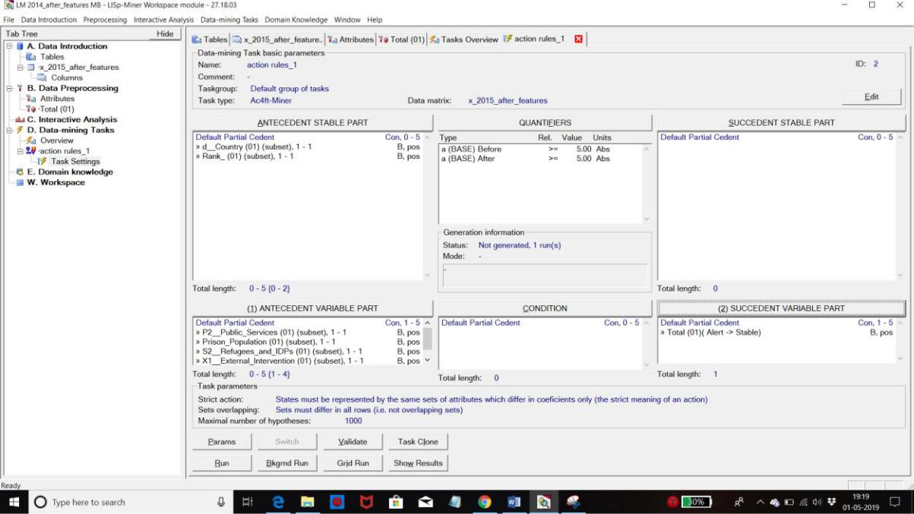

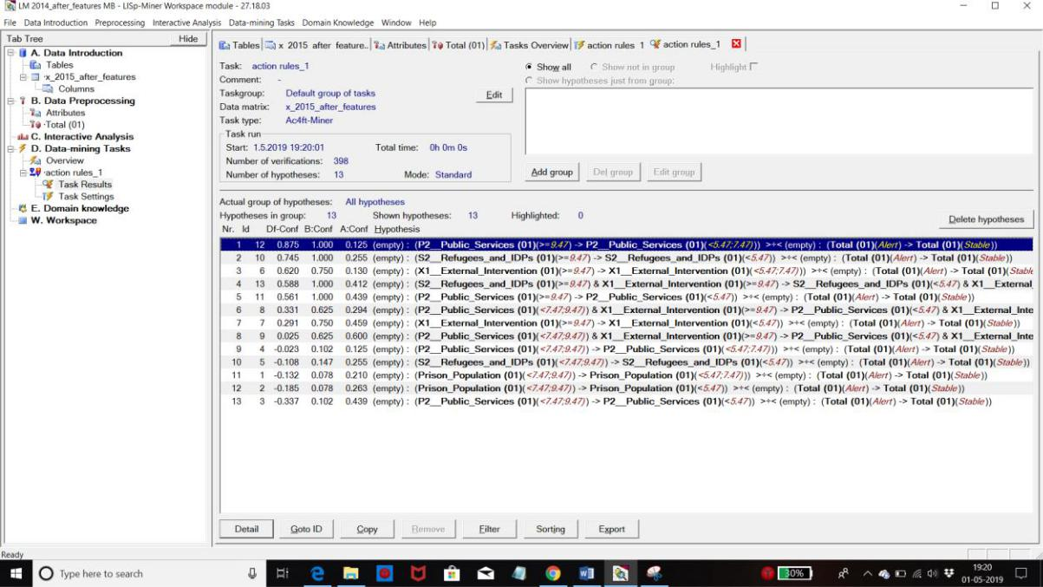

**Rule**

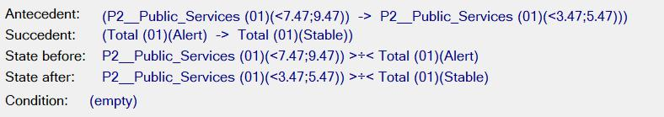

**Text**

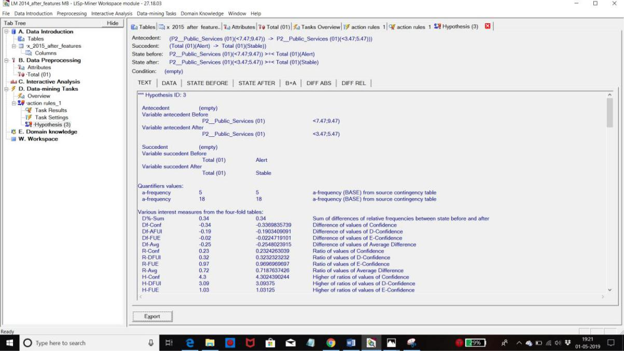

**Data**

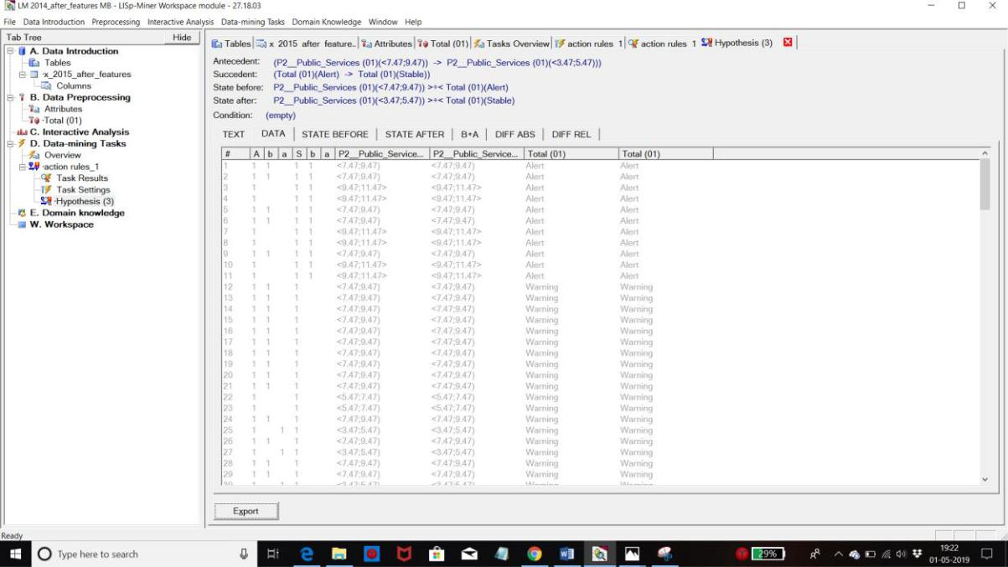

**State Before**

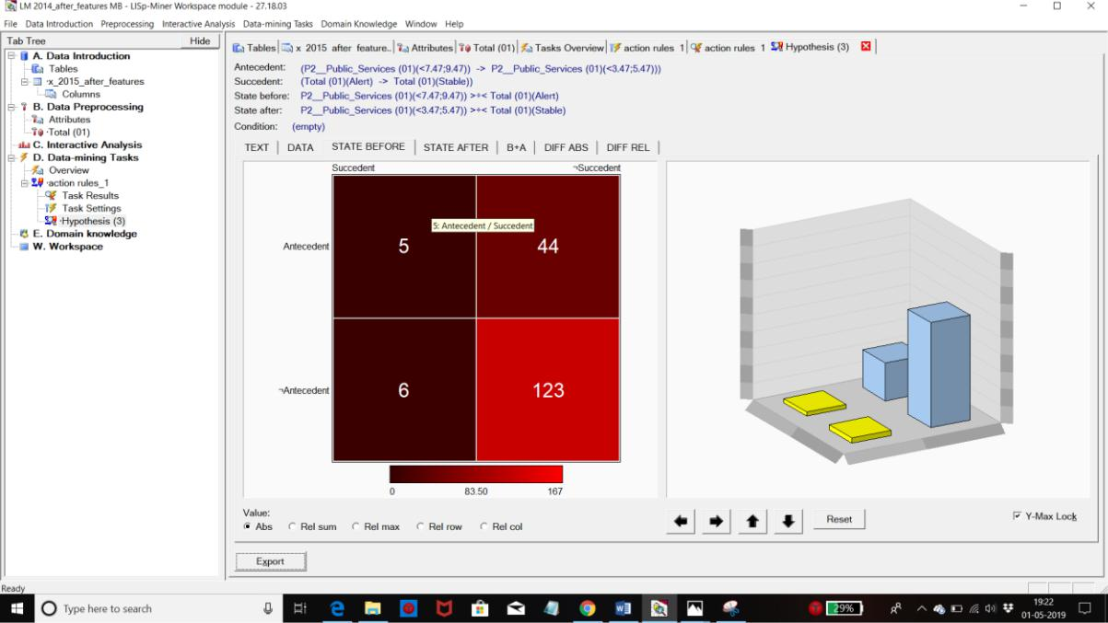

**State After**

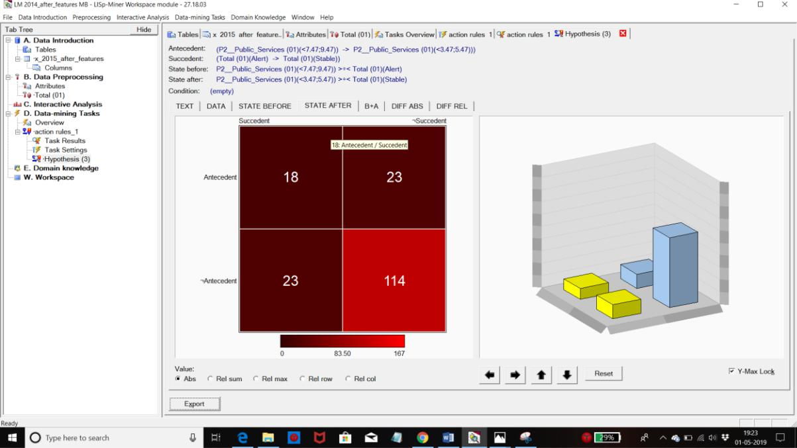

**B + A**

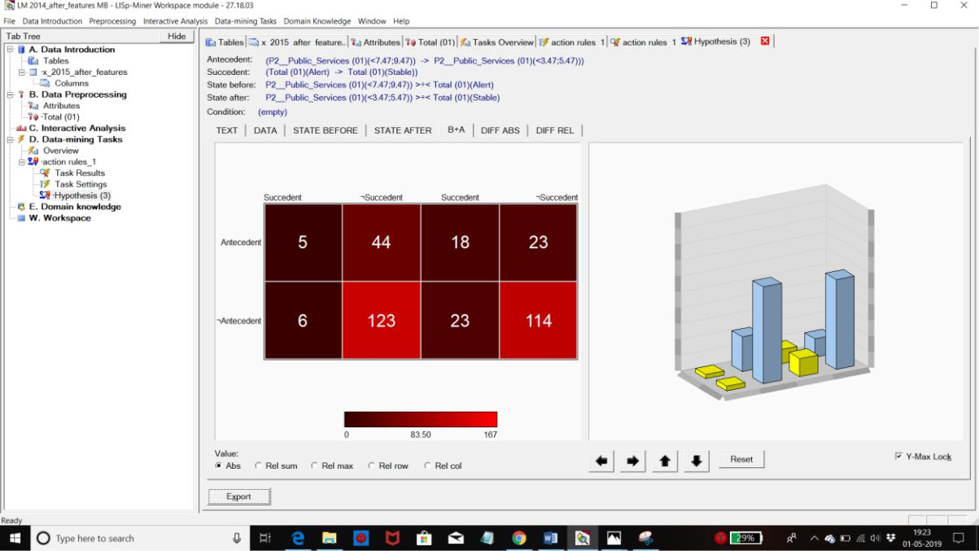

**Diff ABS**

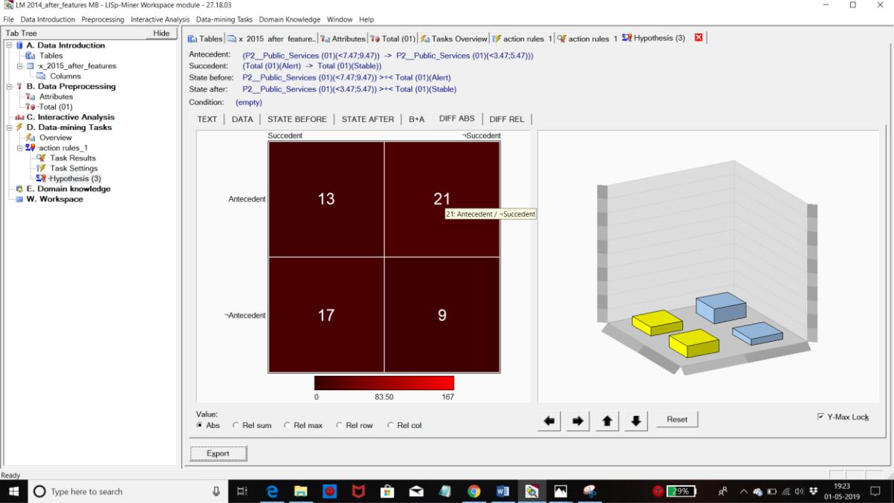

**Diff REL**

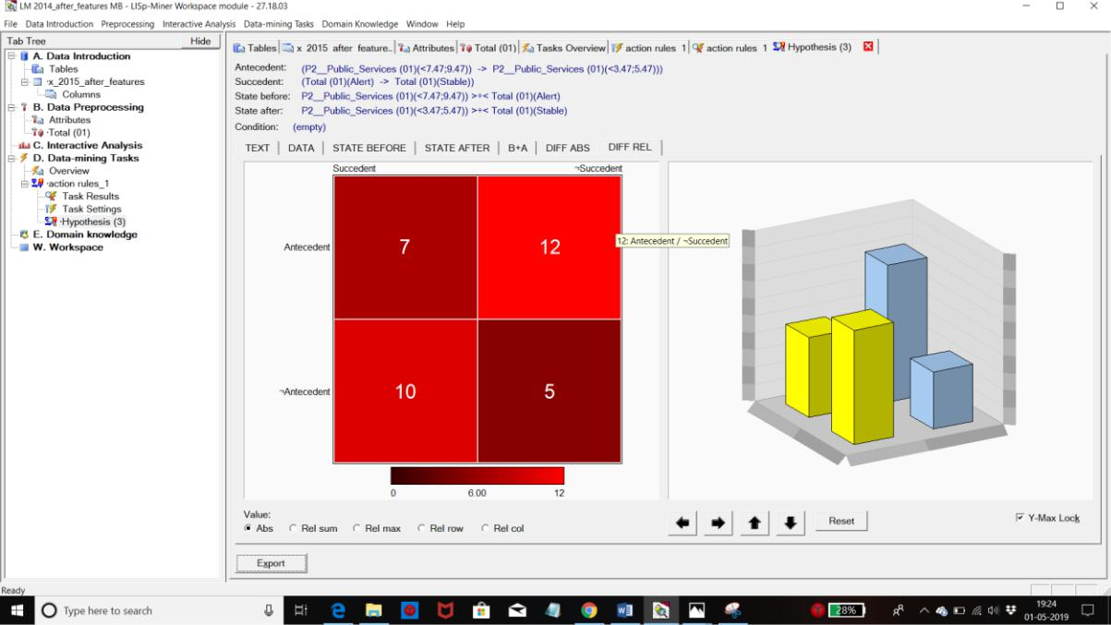

**Stable to Sustainable**

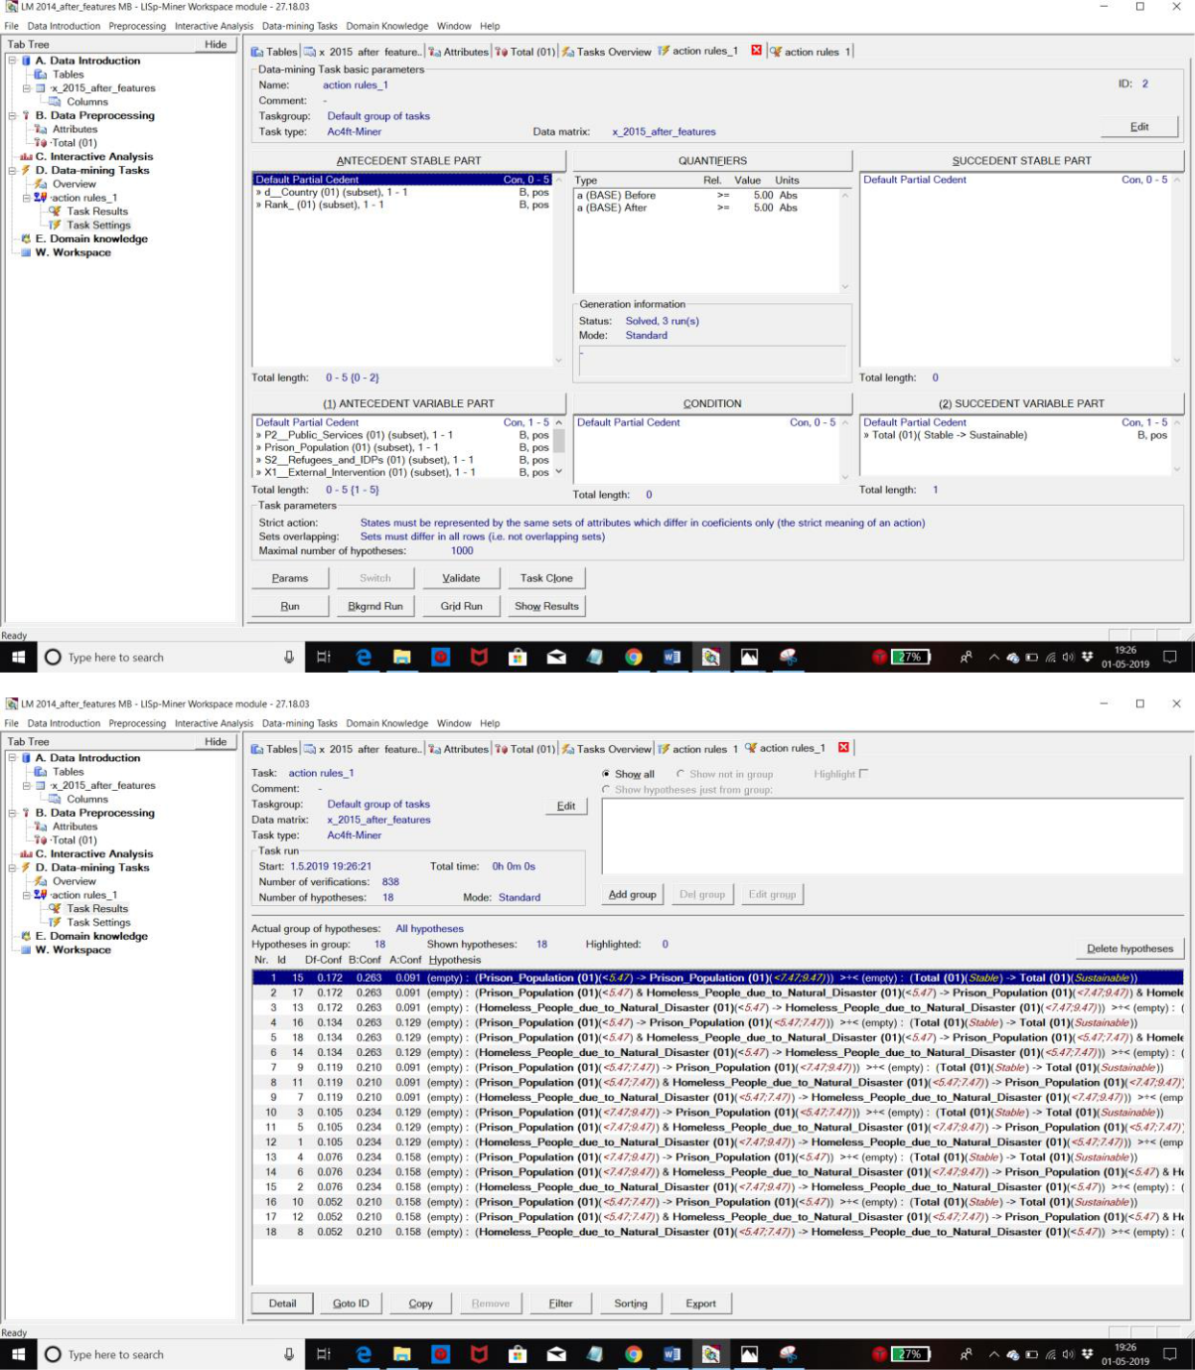



**Rule**

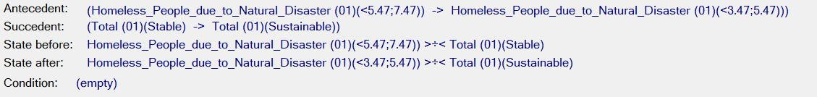

**Text**

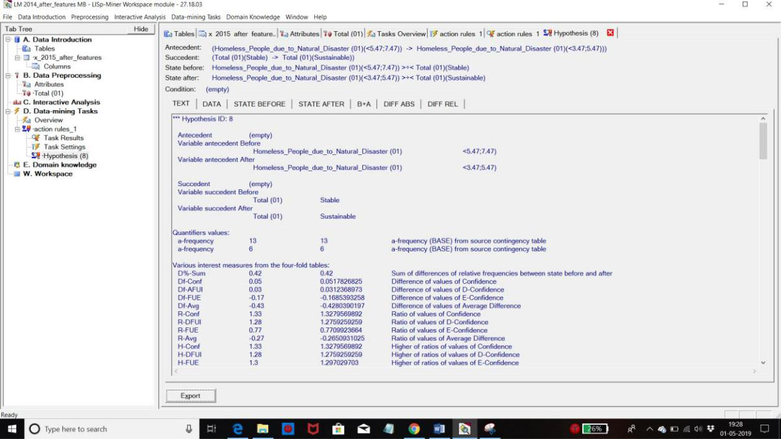

**Data**

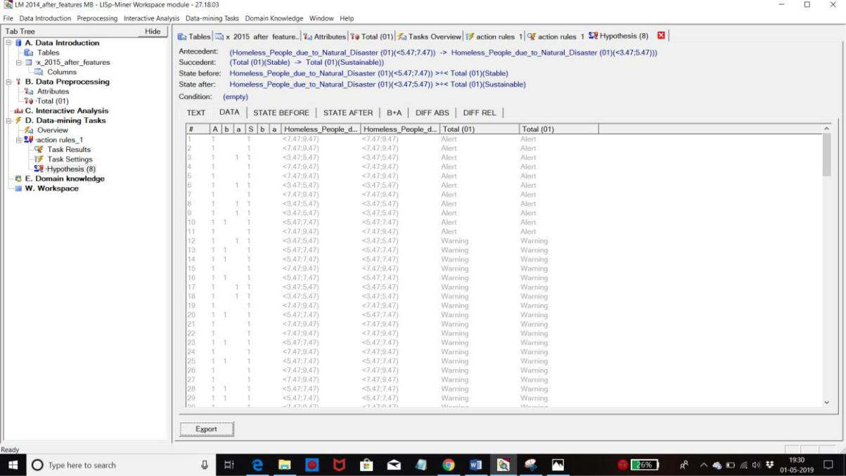

**State Before**

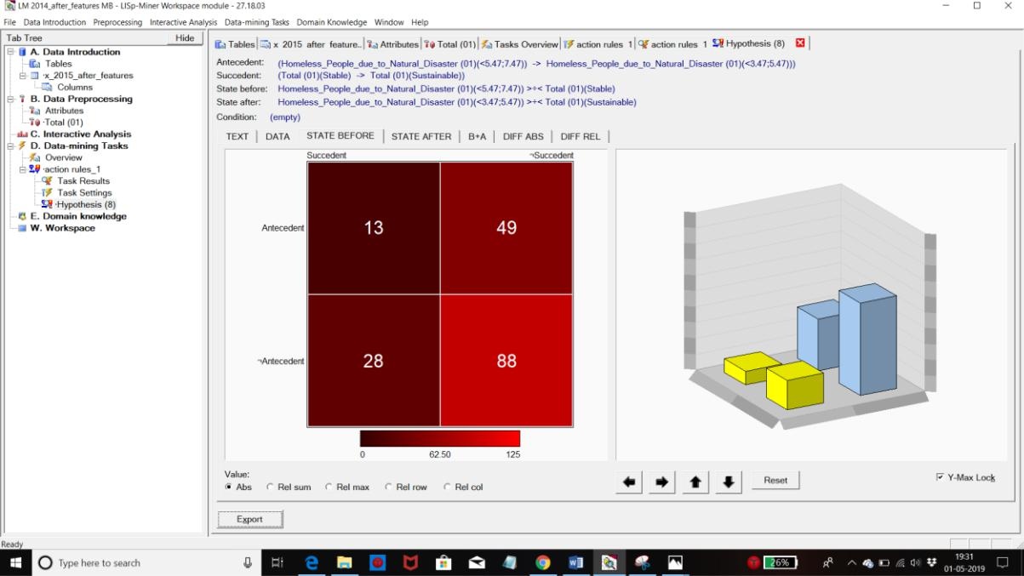

**State After**

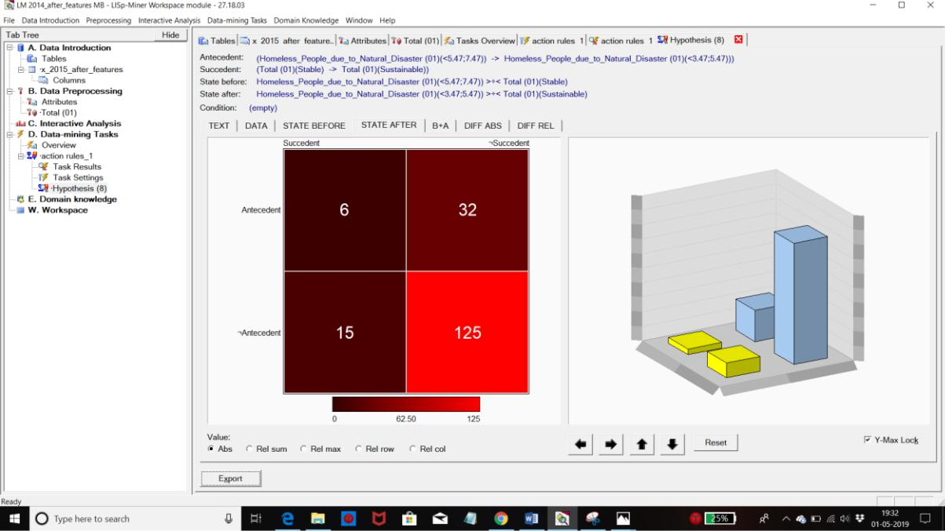

**B + A**

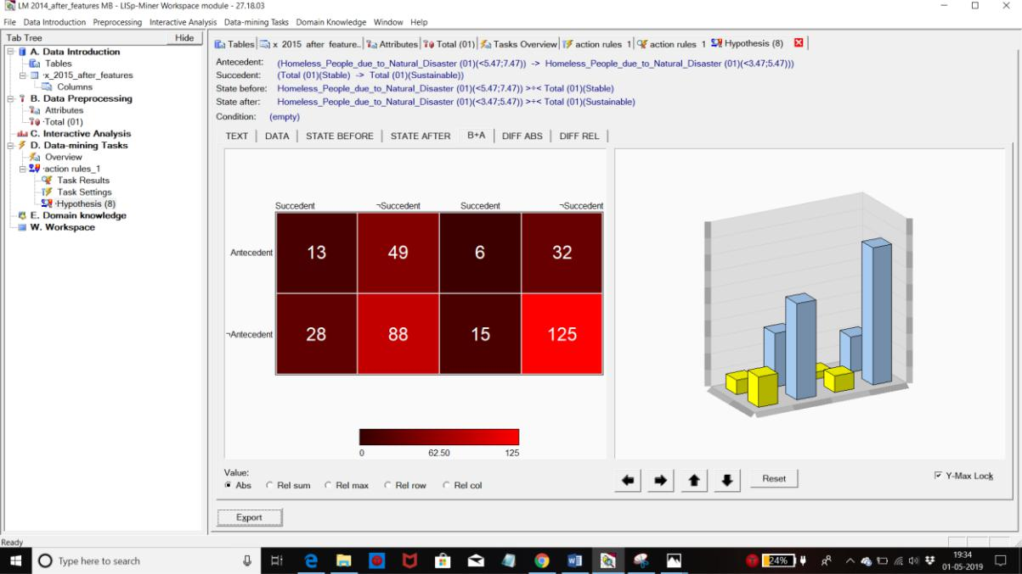

**Diff ABS**

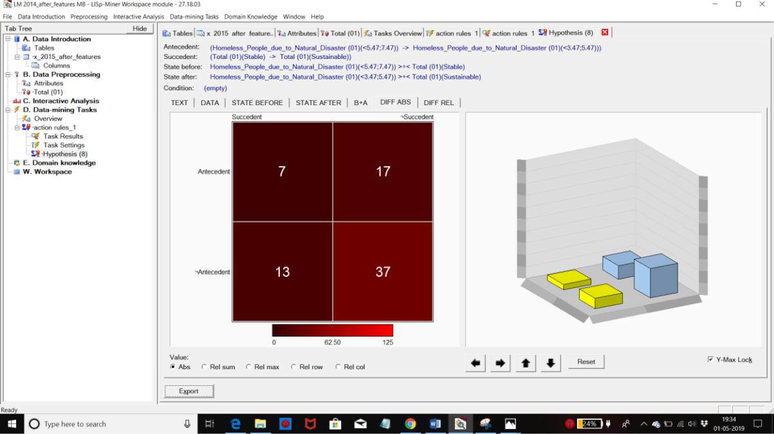

**Diff REL**

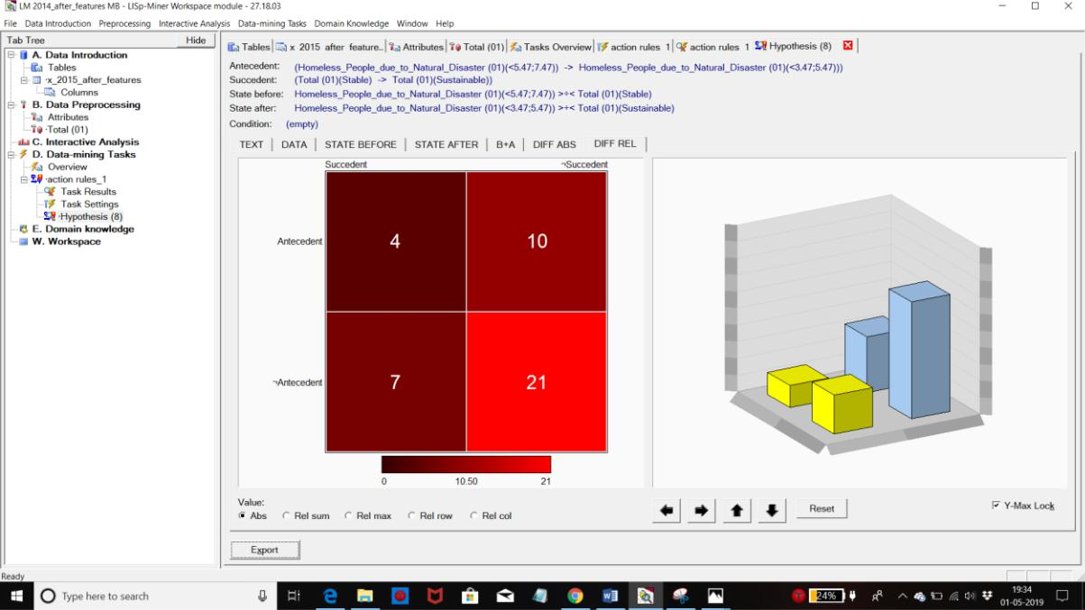

**ACTION RULES FOR 2016**

**Alert to Sustainable**

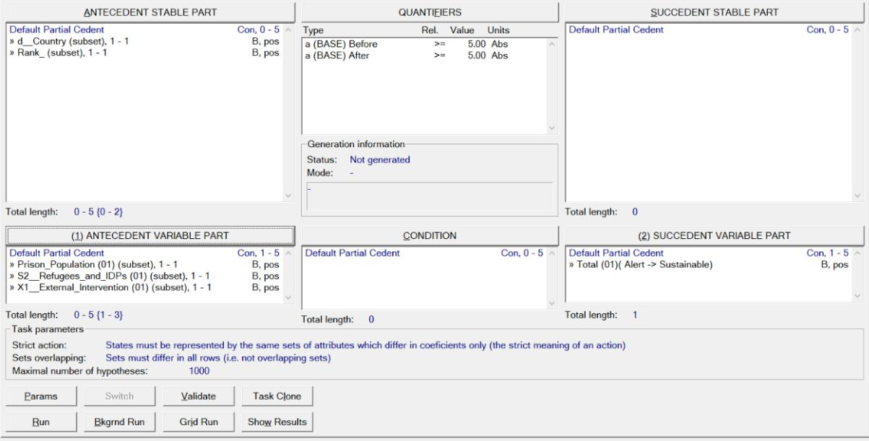

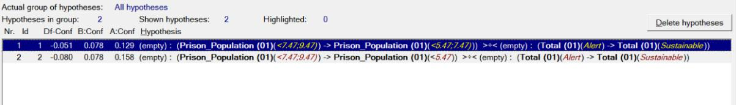

**Rule**

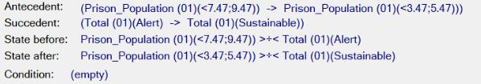

**Text**

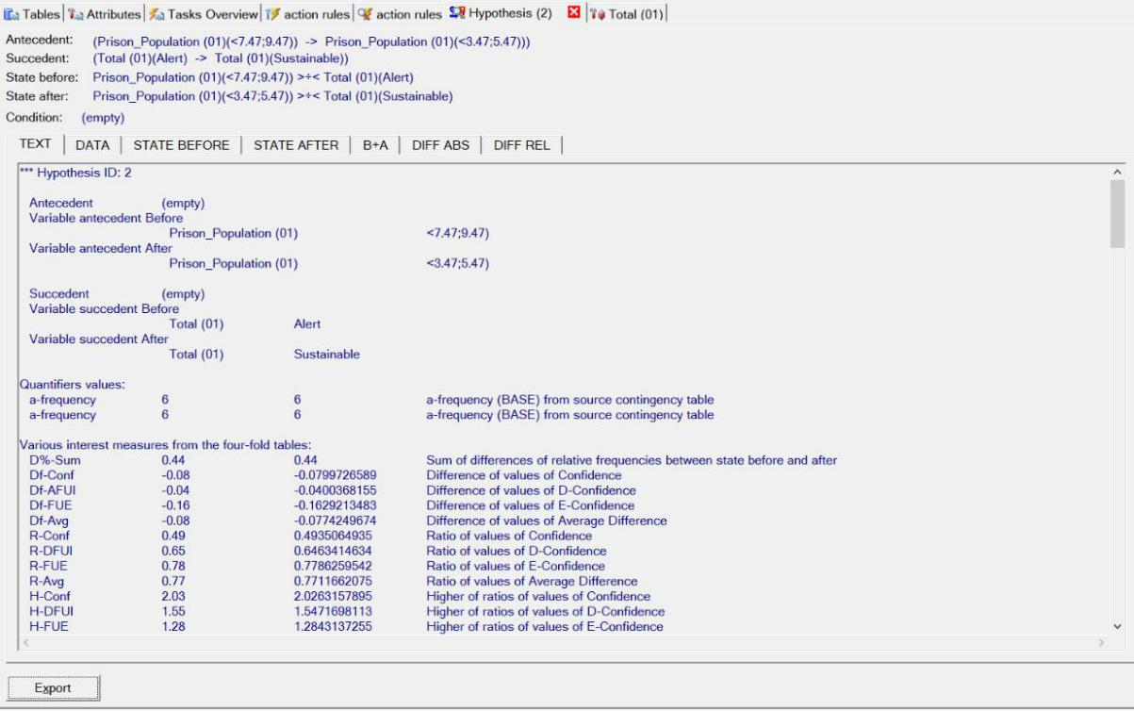

**Data**

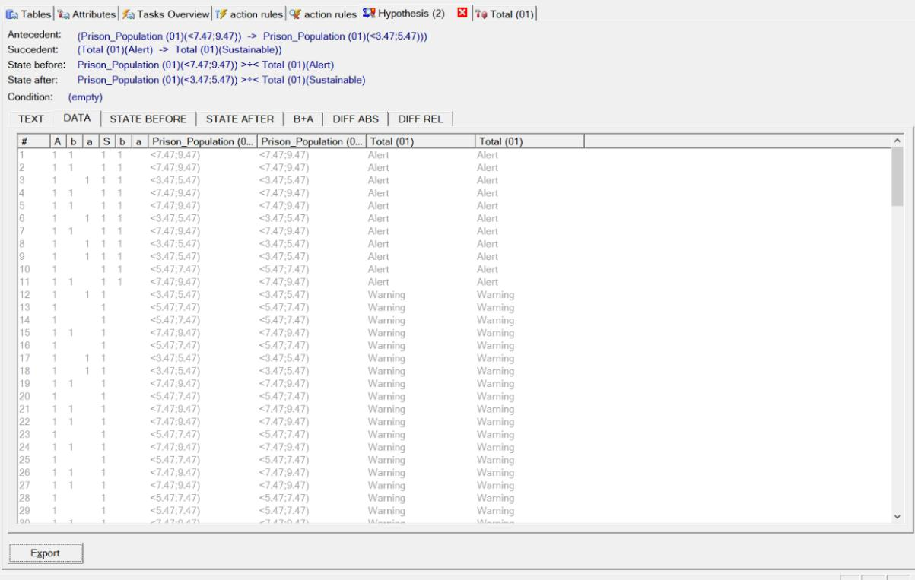

**State Before**

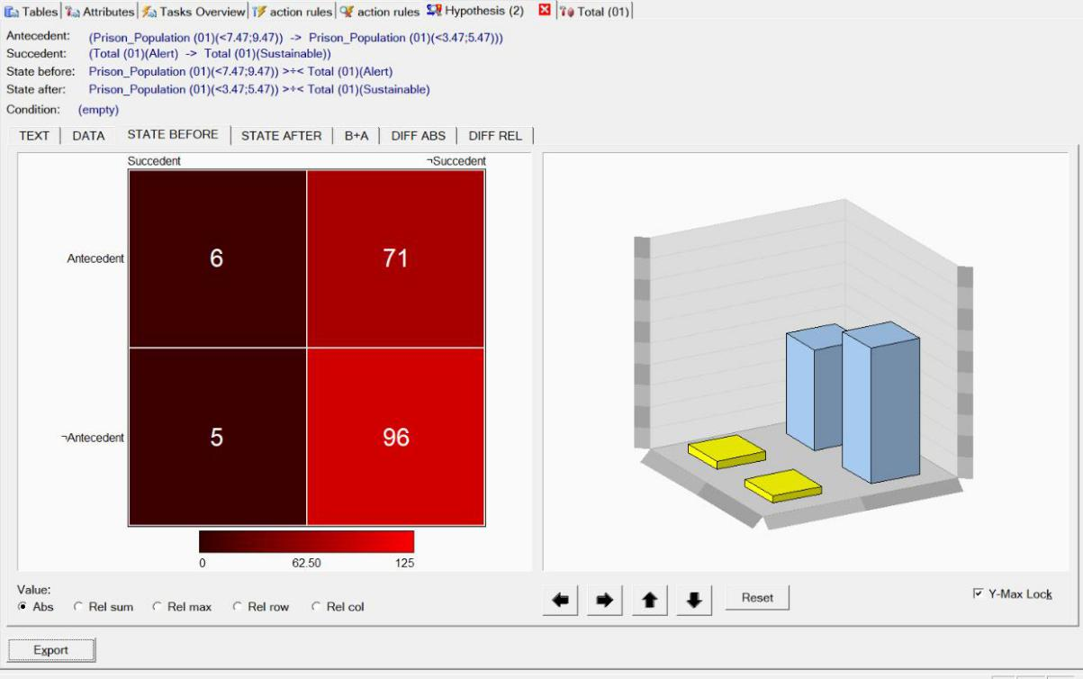

**State After**

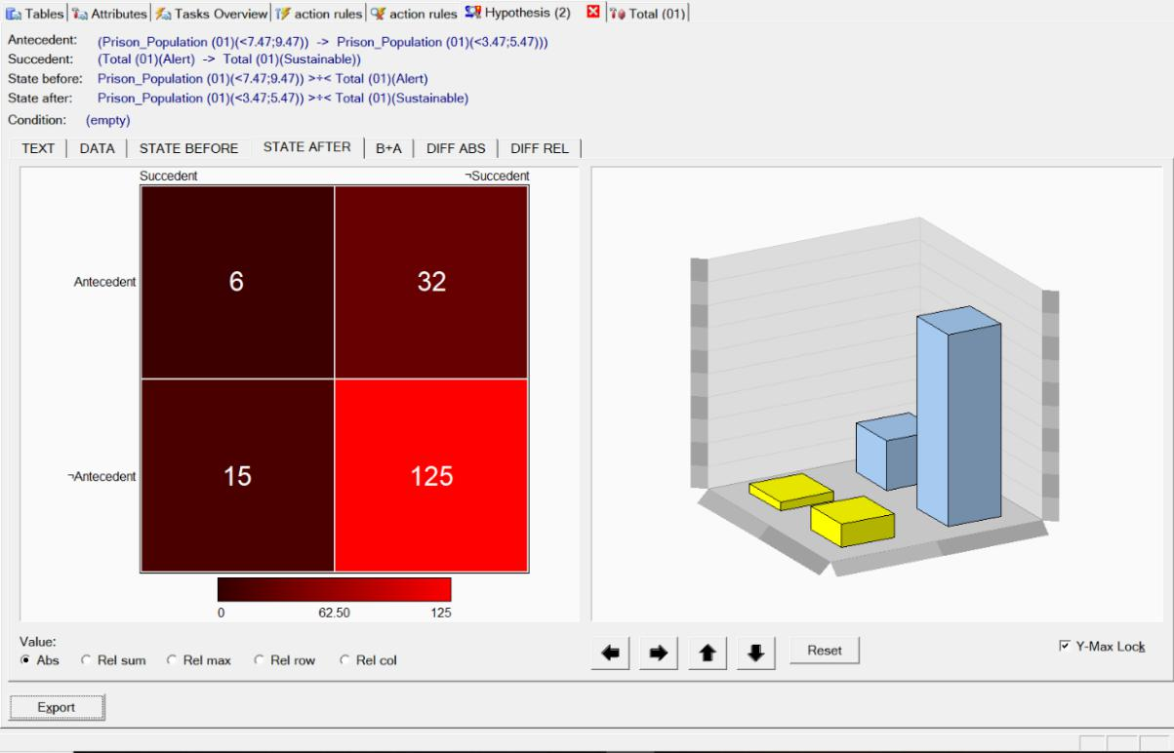

**B + A**

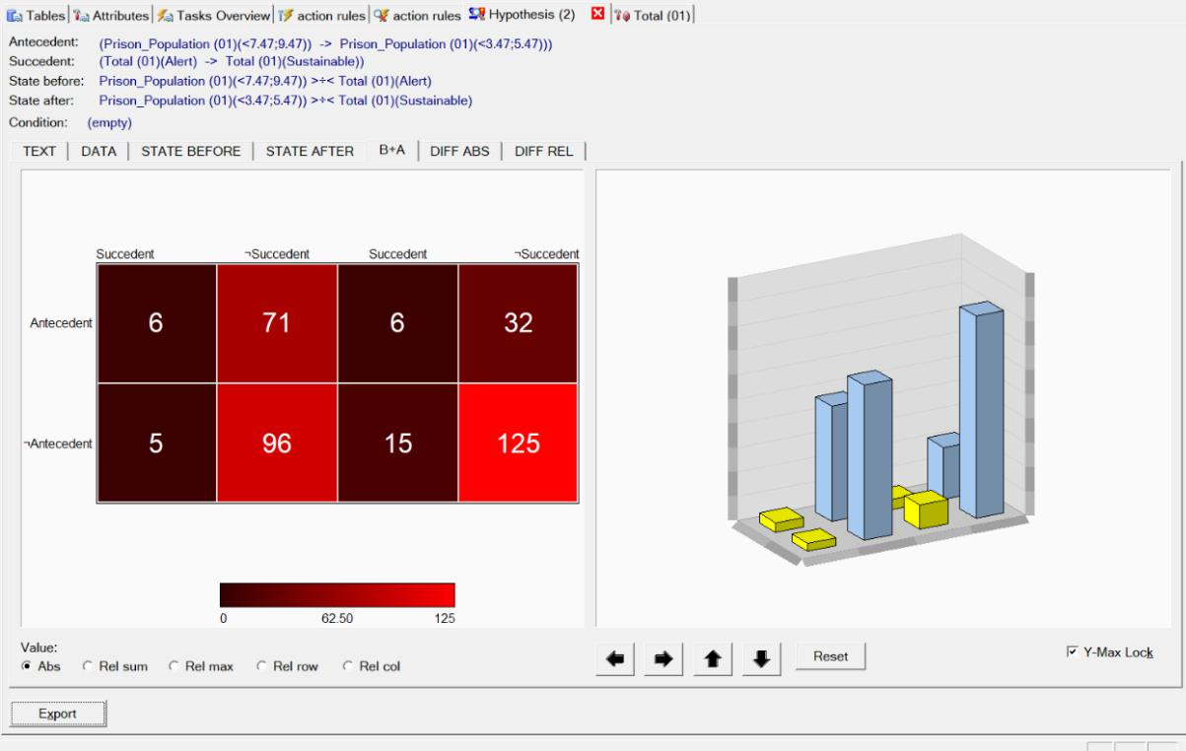

**Diff ABS**

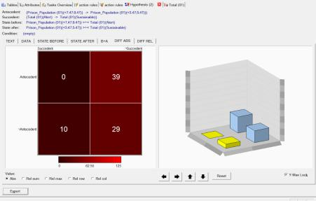

**Diff REL**

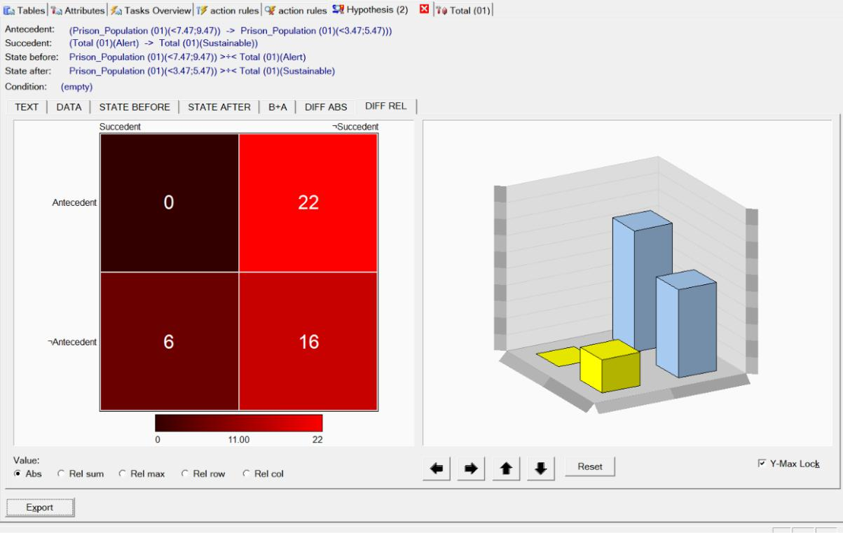

**Stable to Sustainable**

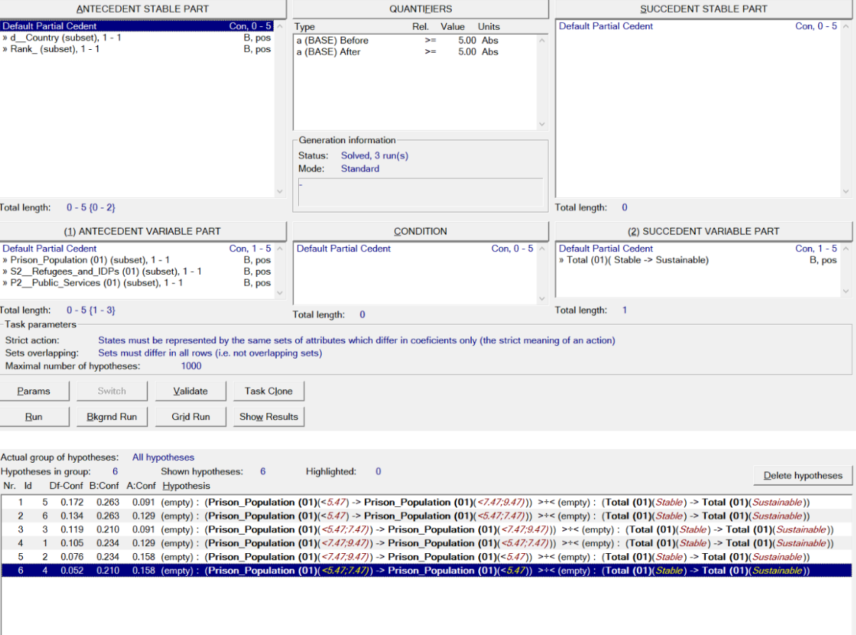

**Rule**

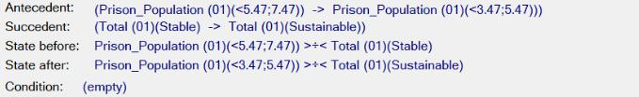

**Text**

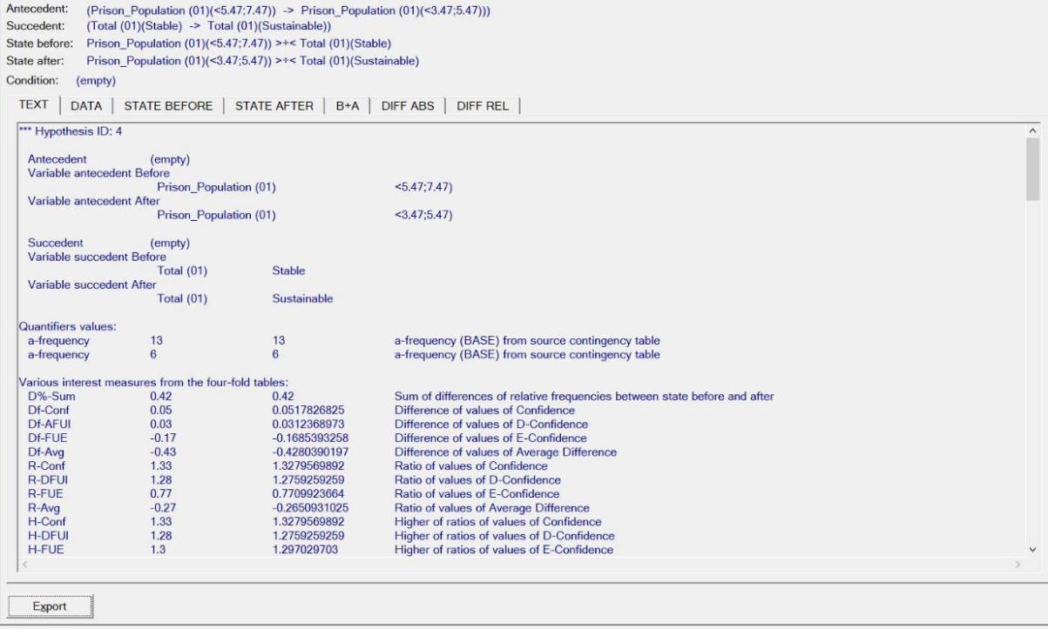

**Data**

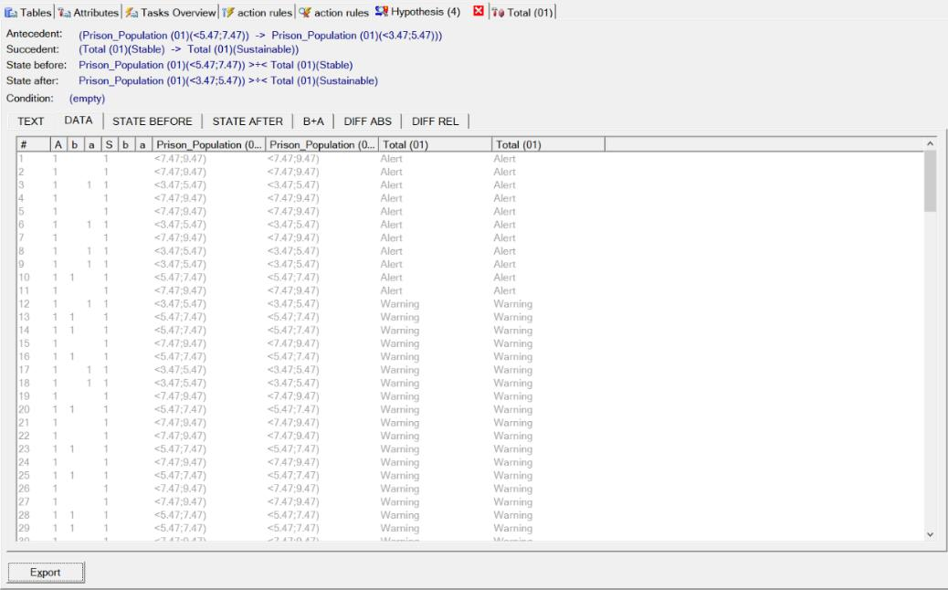

**State Before**

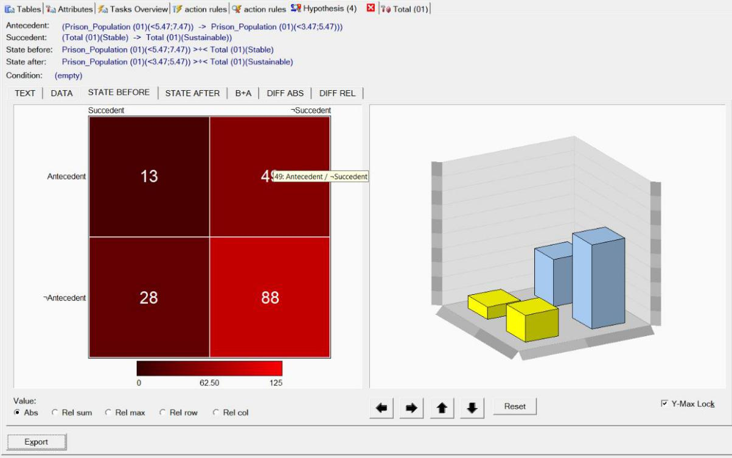

**State After**

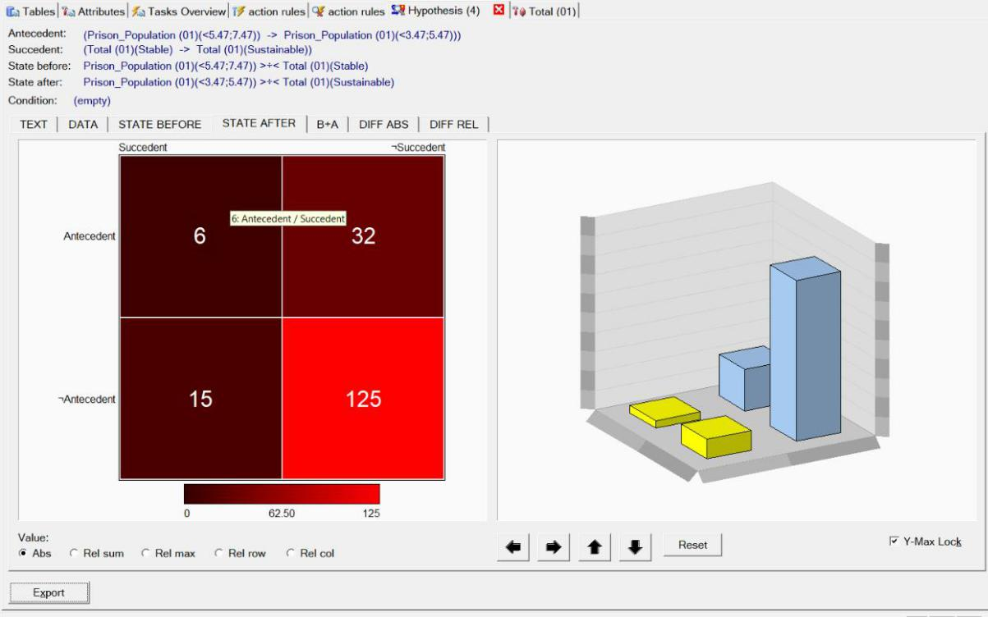

**B + A**

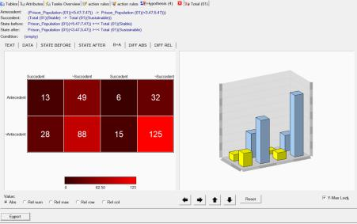

**Diff ABS**

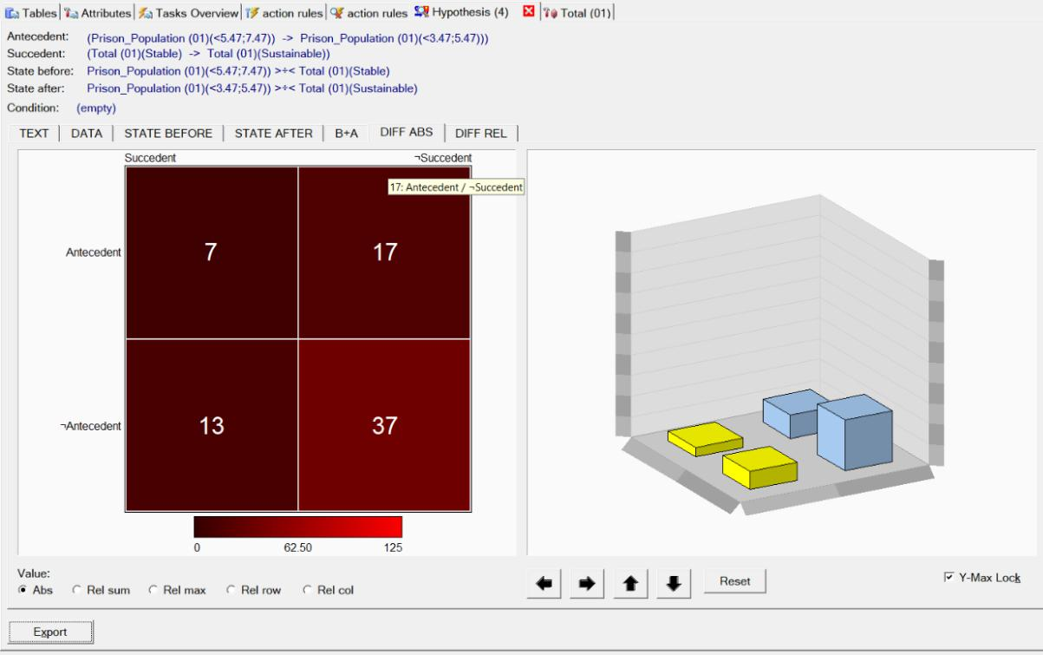

**Diff REL**

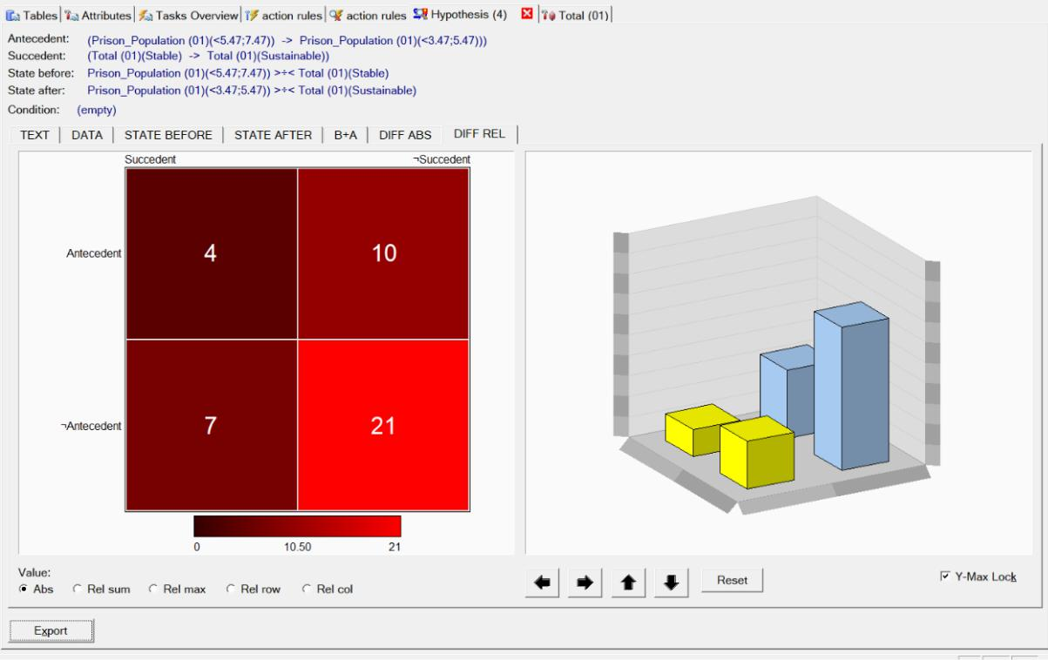

**Alert to Stable**

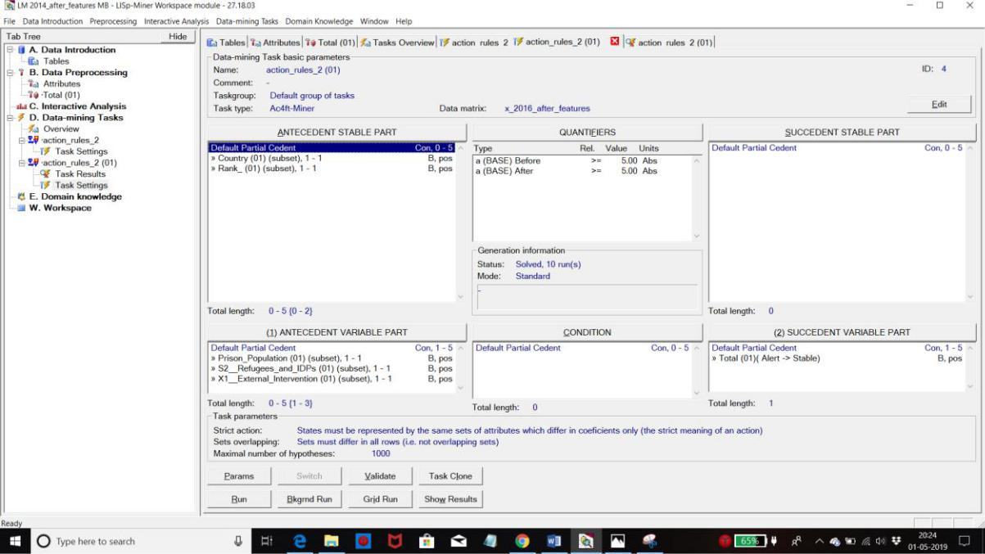

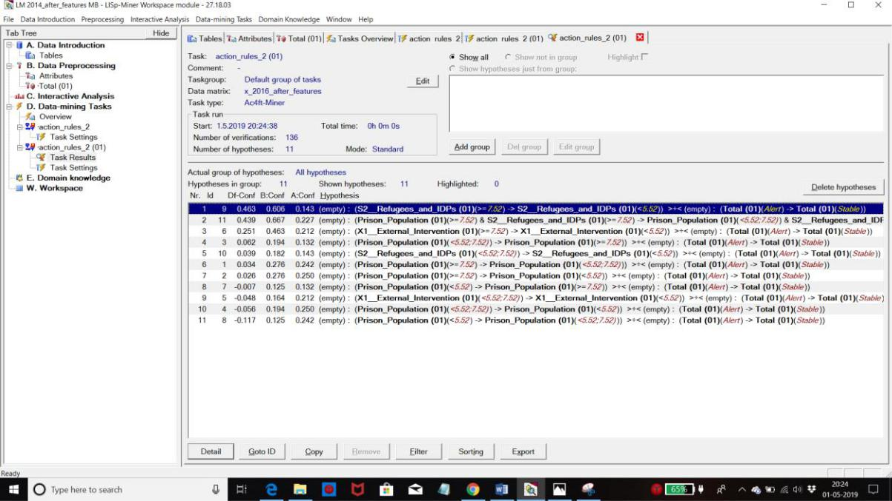

**Rule**

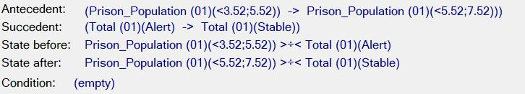

**Text**

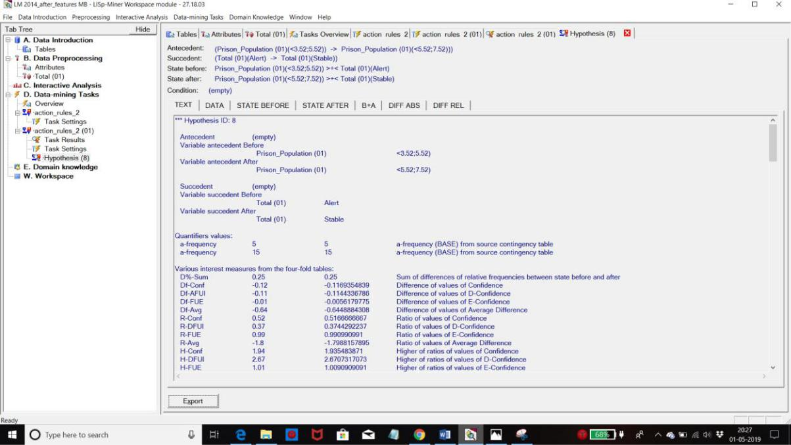

**Data**

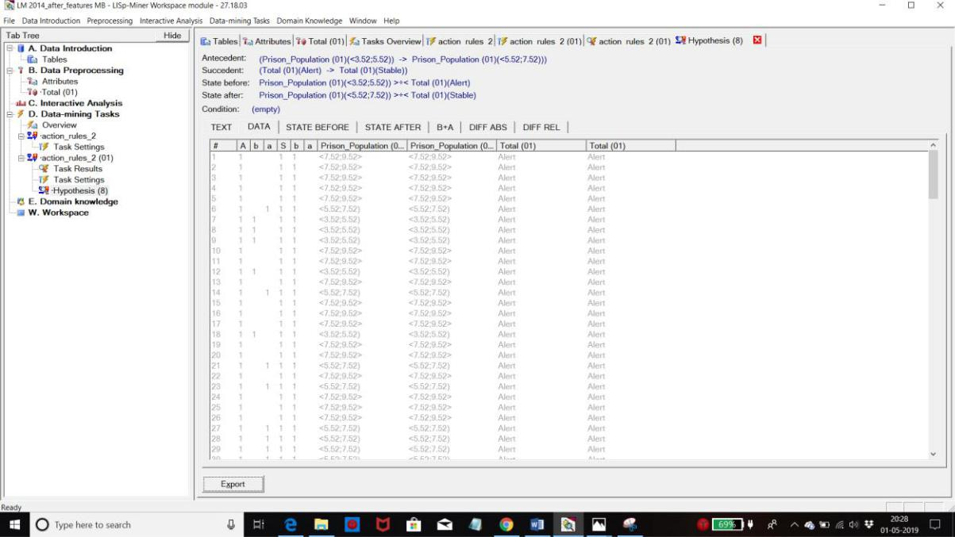

**State Before**

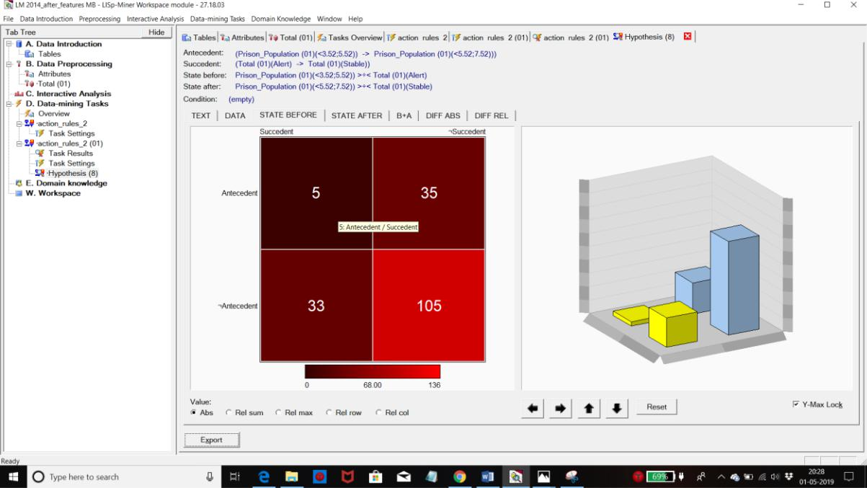

**State After**

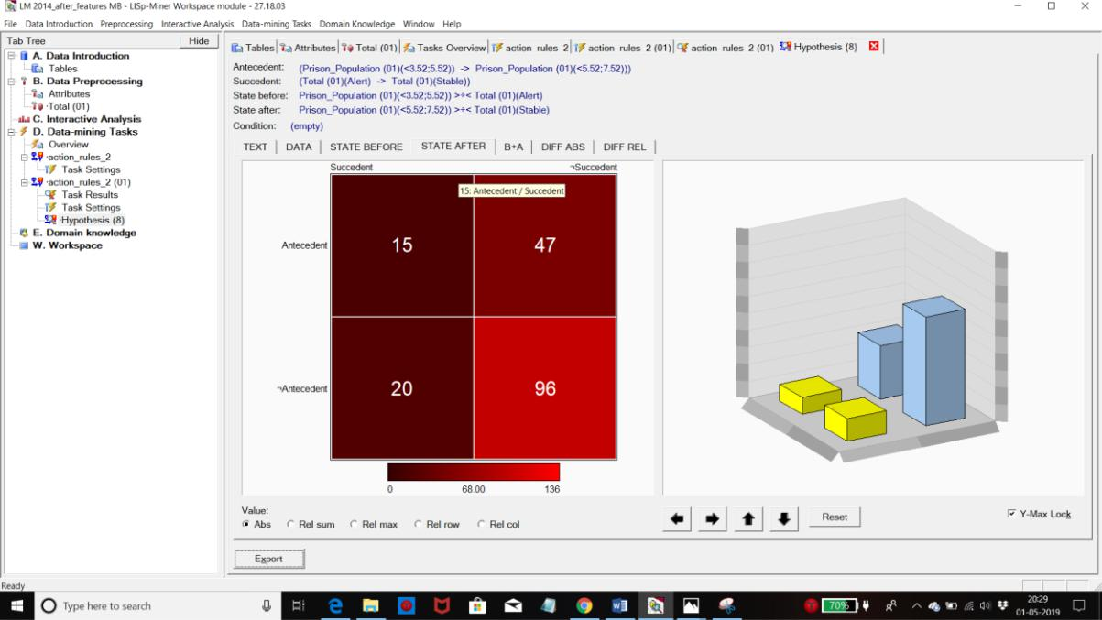

**B + A**

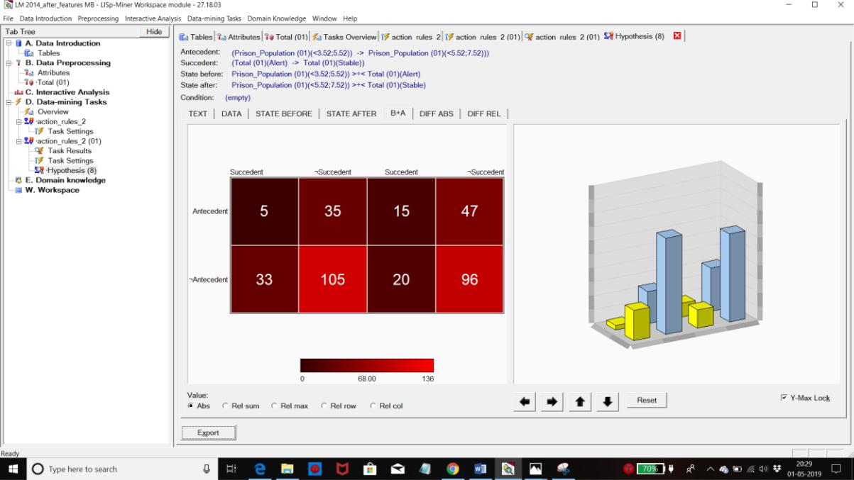

**Diff ABS**

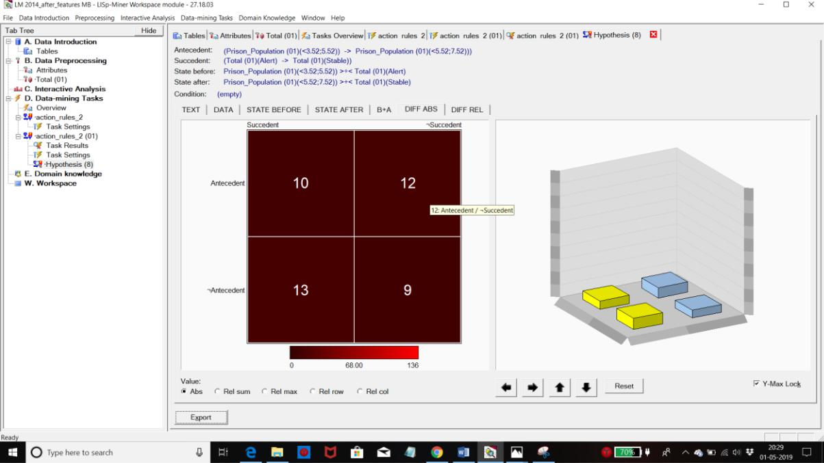

**Diff REL**

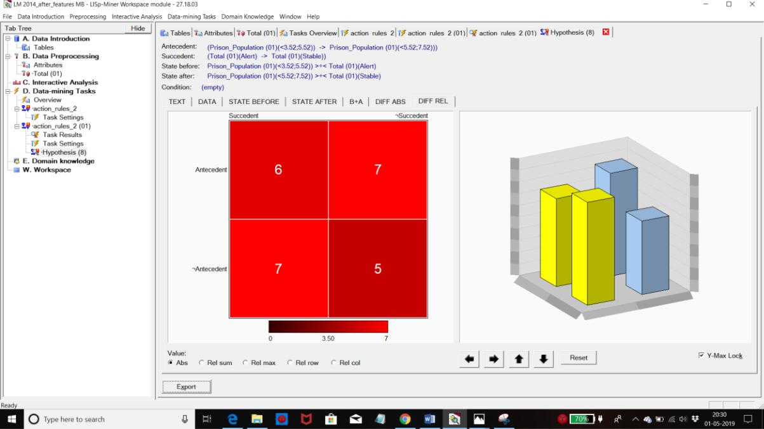

**CONCLUSION**

This added six additional features to the dataset and collected data from various internet sources for those features. Information was washed, pre-processed, arbitrary and sorted by WEKA, and the rules of operation were developed by LISP miner. We found the patterns:

1. For the years 2014-15, the lesser the prison population, the better the FSI for a country. This implies that countries should put in efforts in accelerating the reformation process for criminals so that they can be reintroduced into society. This leads to lesser population in prisons, which ultimately leads to better FSI.
2. For the year 2015, the lesser the homeless people due to natural disasters, the better the FSI for a country. This implies that countries should draft schemes which favors accommodation for the people affected due to disasters as soon as possible.

These action rules can be used to improve the countries by changing their status to less fragile.

**REFERENCES**

<https://fragilestatesindex.org/excel/>

<https://en.wikipedia.org/wiki/Fragile_States_Index>

<https://webpages.uncc.edu/ras/Paper-AR.pdf>

<http://weka.sourceforge.net/doc.dev/weka/classifiers/bayes/BayesNet.html>

<http://databank.worldbank.org/data/home.aspx>

<http://hdr.undp.org/en/data>